

D2.2 Community Building and Management Strategy and Workplan

|  |  |
| --- | --- |
| **Lead Partner:** | Trust-IT, AUTh |
| **Version:** | V2.1.1 |
| **Status:** | Final |
| **Dissemination Level:** | PU |

|  |
| --- |
| **Deliverable Abstract** |
| This deliverable covers the DestinE Community Building Strategy outlining the approach to effectively build, engage and exploit the DestinE User Community while nurturing the ground for the successful exploitation of DestinE DESP capabilities, applications, and solutions by the users. It also deals with the DestinE First Phase Communication Plan which covers the promotional activities for DestinE and to support the community building and activities foreseen as part of the DestinE Use Cases project (DEUC) including the operation of the Joint DestinE Website. |

**COPYRIGHT NOTICE**



**DELIVERY SLIP**

|  |  |  |
| --- | --- | --- |
| *Date* | *Name & Partner* | *Date* |
| Prepared by: | Rob Carrillo (Trust-IT), Eleni Karachaliou (AUTh), Luigi Colucci (Trust-IT), Zachary Smith (Trust-IT), Valeriya Fetisova (Trust-IT) | 30.06.2023 |
| Reviewed by: | Jolanda Patruno (Starion) | 01.12.2023 |
| Approved by: | Antonio Roneo (Starion) | 16/06/2024 |

**DOCUMENT LOG**

|  |  |  |  |
| --- | --- | --- | --- |
| *Issue* | *Date* | *Comment* | *Author* |
| V1.0 | 18.04.2023 | Internal review feedback | Antonio Romeo (Starion) |
| V1.1 | 04.05.2023 | RR review feedback | Efstratios Stylianidis (AUTh), Antonios Mouratidis (AUTh), Eleni Katragkou (AUTh), Antonios Mazaris (AUTh), Eleni Karachaliou (AUTh), Aikaterini Bakousi( AUTh), Costas Bissas (AUTh), Rob Carrillo (Trust-IT) |
| V1.2 | 30.06.2023 | 2nd sub-iteration implementing feedback and updates to the community building and communication plan. | Federico Drago (Trust-IT), Eleni Karachaliou (AUTh) |
| V2.0 | 29.11.2023 | 2nd official iteration of the CBMS | Zachary Smith (Trust-IT), Eleni Karachaliou (AUTh), Rob Carrillo (Trust-IT), Valeriya Fetisova (Trust-IT), Luigi Colucci (Trust-IT) |
| V2.1 | 12.01.2024 | sub-iteration implementing feedback and updates to the community building and communication plan. | Zachary Smith (Trust-IT), Eleni Karachaliou (AUTh), Efstratios Stylianidis (AUTh), Aikaterini Bakousi (AUTh), Zoi-Eirini Tsifodimou (AUTh), Costas Bissas (AUTh), Rob Carrillo (Trust-IT), Valeriya Fetisova (Trust-IT), Luigi Colucci (Trust-IT) |
| V2.1.1 | 18.06.2024 | Implement change of company from RHEA to Starion | Antonio Romeo (Starion) |

**TERMINOLOGY**

|  |  |
| --- | --- |
| *Terminology/Acronym* | *Definition* |
| AI | Artificial intelligence |
| CBMS | Community Building and Management Strategy |
| CoP | Community of Practice |
| DestinE | Destination Earth |
| DESP | DestinE Core Service Platform |
| DEUC | DestinE Use Cases project |
| EE | Entrusted Entities (ESA, ECMWF, EUMETSTAT) |
| GIS | Geographic Information Systems |
| IRL | In Real Life |
| ML | Machine Learning |
| UI | User interface |
| UX | User experience |
| 3Es | Three Entrusted Entities |

**Contents**

1 Introduction 5

2 DestinE Overview and Target Stakeholders 6

2.1 Destination Earth 6

Stakeholder Mapping 7

3 DestinE Community Building Strategy development methodology 15

3.1 Vision, Mission and Values 16

Vision 16

Mission 16

Values 17

3.2 Analysis and evaluation of the external and internal environment of the community 19

External environment (PEST analysis) 19

Internal environment (SWOT analysis) 20

3.3 Strategic Objectives 22

3.4 Short-Term Objectives – 2024 22

4 DestinE Communication and Engagement Plan 34

4.1 Communication and Engagement Objectives 34

4.2 Resources 35

4.3 Communication campaigns 38

5 Monitoring 57

5.1 KPIs dashboard 57

5.2 Matomo analytics 57

5.3 Community database 58

6 Conclusions and next steps 59

7 ANNEX – Previous version of the CBMS 60

Ambition, objectives, and values 60

DestinE Communities of Practice (CoPs) 62

# Introduction

The DestinE Community Management Strategy and Workplan (CBMS) is the document that outlines expectations and procedures for implementing an open stakeholder dialogue within the ESA DestinE Use Cases project (DEUC), in accordance with the DestinE Partnership Plan.

This current version (V2.0) is the second official iteration of the D2.2 Community Building and Management Strategy crystallising the living document updates following feedback received as well as updates based on experience in implementing the strategy and plan.

In Section 2, targeted stakeholders are mapped and categorised. The core of the document is then divided in two parts.

**The first part, Section 3, consists of the DestinE Community Building Strategy** which outlines the approach to effectively build, engage and manage the DestinE User Community while nurturing the ground for the successful exploitation of DestinE DESP capabilities, applications, and solutions by the users.

**The second part, Section 4, deals with the DestinE First Phase Communication Plan** which covers the promotional activities for DestinE and supports the community building activities foreseen as part of the DestinE Use Cases project (DEUC) including the operation of the Joint DestinE Website (formerly the DestinE Community Portal).

The document also provides an overview of how to monitor the progress of the community and engagement activities and concludes with some initial results.

# DestinE Overview and Target Stakeholders

## Destination Earth

DestinE is an initiative of the European Commission to **develop a highly-accurate digital twin of Earth** to model, monitor, and simulate natural and human activity Earth System phenomena and natural hazards to develop and test scenarios that will assist policy-makers in designing accurate and actionable adaptation strategies and mitigation measures for achieving both the [Green Deal](https://ec.europa.eu/info/strategy/priorities-2019-2024/european-green-deal_en) and the [Digital Strategy](https://ec.europa.eu/info/strategy/priorities-2019-2024/europe-fit-digital-age/european-data-strategy_en) priorities of the EU:

* **DestinE will anticipate both natural disasters and man-made environmental damage** with ever higher accuracy. It will identify and assess the negative impacts of natural disasters and environmental damage on various socio-economic sectors and geographical regions. In other words, DestinE will integrate ‘cause and effect’ – combining better forecasts of potential environmental disasters with their expected adverse impacts on human activity.
* **DestinE will enable the continuous and accurate monitoring of the health of the planet** by focusing on the countless effects of climate change on, e.g., the oceans, water resources, the Earth’s ice caps, biodiversity, land use, and other natural resources.
* **DestinE will allow to better understand the socio-economic effects of climate change and the occurrence of extreme natural disasters**. For example, between 1980 and 2017, floods, droughts, heat waves and other climate-related extremes caused economic losses in excess of €420 billion and have claimed the lives of more than 115,000 people across Europe.
* **DestinE will help adapting to climate change related challenges** by providing a common **infrastructure for the users at various levels** for supporting informed and actionable decision-making for policy measures, for example, to assess the real impact and efficiency of environmental policies and related legislative measures.

In the Commission’s Data Strategy of 2020, DestinE is highlighted as an initiative that will cover concrete actions in the context of the Green Deal Data Space and in support of the Green Deal objectives.

DestinE will be implemented gradually over the next 7-10 years. The activities funded by the [DIGITAL Work Progamme 2021-2022](https://digital-strategy.ec.europa.eu/en/activities/work-programmes-digital) will focus on the deployment of the Core Service Platform and the Data Lake, the building of the Digital Twin Engine and the implementation of the first two Digital Twins on Weather-induced & Geophysical Extremes and on Climate Change Adaptation that will be integrated into the platform. In later stages, these initial components will be complemented by additional digital twins, tools and applications by research institutions, private sector and civil society. Additional funding will be available from other sources, e.g., the Horizon Europe Programme.

DestinE will also have a clear interface with the European Union’s flagship Space programme Copernicus and its relevant resources.

## Stakeholder Mapping

The DestinE stakeholders will contribute to the design and development of the system through a co-design process to ensure that the system responds to real user needs and provides novelty in comparison to their current operational environments.

Considering the size and goals of the DestinE initiative, the user community shall be composed of multiple and diverse types of stakeholders.

The classification of the stakeholders for the stakeholders’ mapping will be based on three different levels, the spatial, their expertise, and the customised one.

The spatial categorisation will be used for policy and decision makers, while the expertise will apply to the research and academia, technology providers, and industry. The DestinE Use case makers, the Core DestinE Entities, and the general public have a special classification of their own, as they apply to different categorisations and peculiarities. A visual representation of the above stakeholders’ categories is seen in Figure 1.

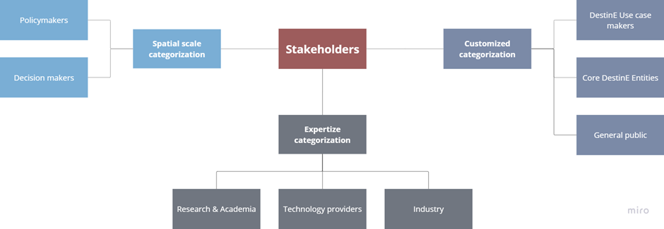

Figure 1 Stakeholder categorisation

### Categorisation based on a spatial scale

Using a spatial approach to generate a stakeholders' map is important for several reasons. First, different stakeholders may have different levels of interest and influence depending on the spatial scale. For example, local stakeholders such as community groups and NGOs may be more influential at the local and regional scales, while national governments and international organisations may have more influence at the national and global scales. By considering stakeholders at different spatial scales, the DestinE initiative can ensure that it is engaging with the right stakeholders at the right levels of decision-making. Second, DestinE aims to provide insights and solutions that are applicable at different spatial scales. For example, the project may provide local decision-makers with information and tools to improve disaster risk management and adaptation, while also providing global decision-makers with information on the impacts of the climate crisis on a global scale. By considering stakeholders at different spatial scales, the project can ensure that the insights and solutions it provides are relevant and applicable to different decision-makers and contexts. Moreover, considering stakeholders at different spatial scales can help to identify potential conflicts and trade-offs between different stakeholders and scales. By considering stakeholders at different spatial scales, DestinE can identify potential conflicts and work to develop solutions that are beneficial at multiple scales. Last but not least, engaging stakeholders at an ecoregion level is expected to be vital, considering that areas that are identified as similar require a similar course of action.

#### Policymakers

Policymakers, including representatives from government agencies and international organisations, may be interested in using the data and insights to inform policy development and implementation. They may have a strong interest in understanding the impacts of the climate crisis and extreme weather events, and how they can be mitigated and adapted to. Policymakers are key stakeholders and main beneficiaries of the DestinE initiative, as it provides them with a powerful and unique tool for analysis and prediction, to make data-driven policy decisions. As the EU works toward its goal of being carbon neutral by 2050, DestinE initiative will serve as the foundation for successful European adaptation strategies in support of the European Commission’s.

Policymakers are considered key users of the DESP. Thus, policymakers' needs identification is critical. Their specific classification is shown in Figure 2 and may occur as follows:

* **Local policymakers**: city councils, local governments responsible for managing natural resources, local environmental agencies i.e., environmental protection departments.
* **Regional policymakers**: regional authorities responsible for managing natural resources i.e., regional councils for the environment and sustainable development.
* **National policymakers**: national ministries of environment, national meteorological and hydrological services, members of parliament, officials from relevant national departments, and civil protection services, emergency services.
* **Continental scale policymakers**: European Emergency Coordination Center, European Commission's Directorate-General for climate action, the European Environment Agency, members of the European Parliament, representatives of the European Commission and other EU bodies, officials from intergovernmental organisations operating at the continental level, representatives of national governments and authorities.
* **Ecoregions policymakers**: representatives of organisations working at the level of the 14 major ecoregions.
* **Global scale policymakers**: representatives of the United Nations and its agencies, officials from intergovernmental organisations working at the global level, and representatives of international NGOs working on global issues.

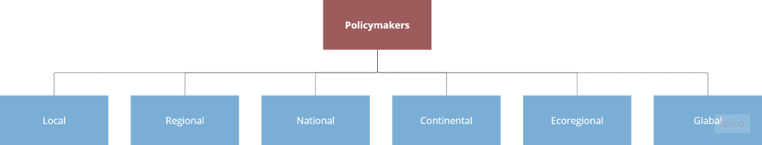

Figure 2 Policymakers breakdown

#### Decision makers

Decision makers, including high-level government officials and business leaders, may have a strong interest in DestinE as it has the potential to inform and guide policy decisions related to the twin, green and digital transition. They may also be interested in the potential economic benefits of the DESP, such as increased efficiency and productivity, and job creation. Decision makers are also considered key users of the DESP and their needs identification is important.

Decision makers are likely to be key supporters of the DestinE initiative, setting them as an early engagement stakeholder. Their specific classification is shown in Figure 3 and may occur as follows:

* Local scale decision makers: city planners, business owners and managers, and community leaders, such as non-profit organisation leaders
* Regional scale decision makers: regional managers, chamber of commerce members, and representatives of non-governmental organisations
* National level decision makers: corporate executives, investment bankers, venture capitalists, and business leaders (e.g., CEOs, CTOs)
* Continental level decision makers: European business leaders, investors, representatives of intergovernmental organisations and representatives of regional development banks.
* Ecoregion decision makers: experts and practitioners with knowledge of specific ecoregions and their particular challenges and representatives of indigenous and other local communities.
* Global scale decision makers: global business CEOs and other executives of major global corporations, and representatives of international organisations focused on climate and the environment.

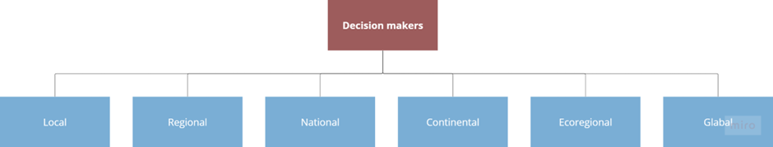

Figure 3 Decision makers breakdown

### Categorisation based on the area of expertise

#### Research and academia

Researchers and academics may be interested in using the data and tools provided by DESP to advance scientific knowledge and understanding of the earth. They may be interested in using DESP to exchange knowledge, conduct research, validate models, and test hypotheses. Research and academia are a key stakeholders and beneficiaries of the DESP platform, as access to the data used and produced as part of the Digital Twins will provide researchers with the tools to comprehend the intricate roles that the environment and people will play in determining the earth’s future, and open up a range of new research questions.

Research and academia stakeholders can have different subcategories on different spatial levels, depending on the focus of their research and their geographical scope. However, in the case of the DestinE initiative, the nature of the research and the digital twin approach make it less relevant to differentiate between research and academia stakeholders based on their spatial location. The research and academia stakeholders involved in DestinE are likely to have expertise in specific fields, such as climate science, hydrology, geology, and atmospheric science, rather than being defined by their spatial location. The same hydrologist, for example, may conduct research at a local, regional, or global scale depending on their research focus and the availability of data. Therefore, in the context of the DESP, it may be more relevant to classify research and academia stakeholders based on their areas of expertise rather than their spatial location. Based on that, the research and academia classification may include a vast variety of subcategories such as:

* Climate scientists
* Meteorologists
* Ecologists
* Hydrologists
* Environmental economists
* Social scientists
* Data scientists
* Environmental scientists
* Computer scientists
* Engineers
* Agronomists
* Biologists

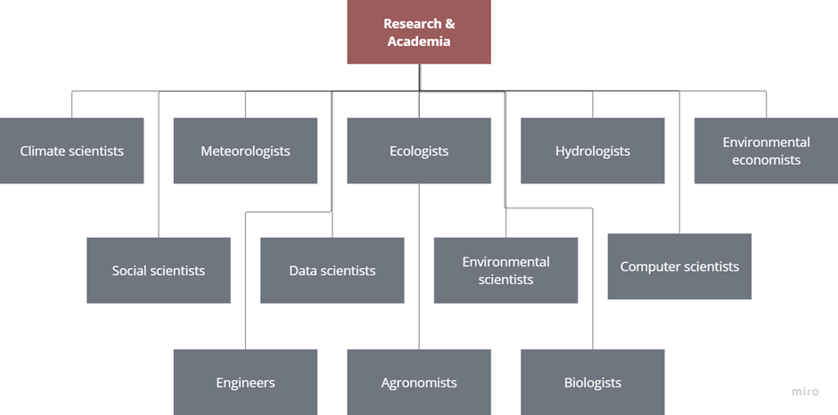 Figure 4 Indicative research and academia subcategories

Figure 4 shows indicative subcategories of research and academia. For each of these subcategories, the specific stakeholders involved may vary depending on the spatial level in question. For example, at a local level, climate scientists may include professors at a nearby university, meteorologists may include forecasters at a local station, and ecologists may include researchers at a nearby nature preserve. At a national level, these stakeholders may include researchers at government agencies, and at a global level, they may include scientists at international research institutions. For the 14 major ecoregions, specific stakeholders may include representatives from local environmental NGOs, universities with research programs in the region, and government agencies responsible for managing the region's natural resources.

#### Technology providers

Technology providers, including companies that provide hardware and software solutions, may be interested in both providing tools and resources to support the development and implementation of DestinE and to use the tools and resources provided by DestinE for their own benefits. They may be interested in partnering with DestinE to provide data processing and storage solutions, as well as analytical tools and algorithms. Technology providers may be concerned about issues related to data privacy and security, as well as the potential for competition from other providers.

Technology providers may operate at all levels, from local to global. However, their services and solutions may be more relevant and tailored to specific spatial scales. For example, a GIS provider may focus more on local and regional applications, while a remote sensing technology provider may have a global reach. In the context of the DestinE project it may be more relevant to classify technology providers based on the services they provide rather than their spatial location. Ostensive the following are referred:

* Geographic Information Systems (GIS) providers
* Remote sensing technology providers
* Artificial Intelligence (AI) and Machine Learning (ML) providers
* Simulation and modelling software providers
* Visualisation and User Interface (UI) providers
* Cybersecurity and data privacy providers
* Cloud computing providers
* HPC providers
* Other software companies
* Hardware companies

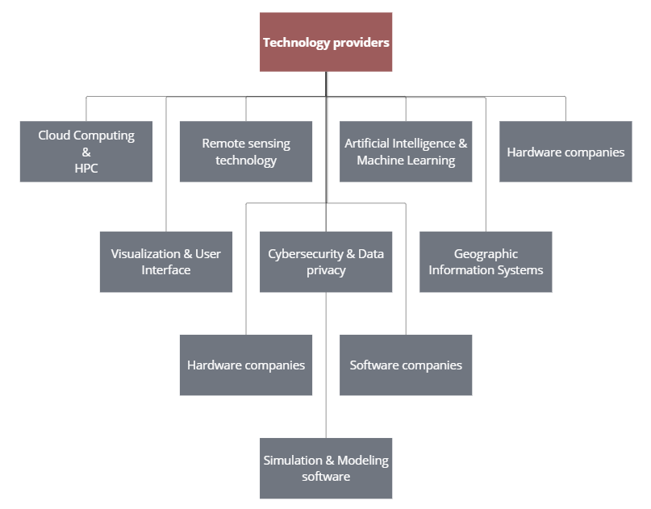

Figure 5 Indicative technology providers subcategories

Figure 5 shows indicative subcategories of technology providers. Unlike other stakeholder categories, technology providers do not have different subcategories on different spatial levels because their services are not necessarily limited to a specific geographic location. Technology providers can provide their services globally, and their solutions can be applied to various spatial scales. However, the specific solutions they offer may vary based on the needs and characteristics of different regions or ecosystems.

#### Industry

Industry, including companies such as energy, agriculture, and transportation, amongst many others may be interested in using the data and insights offered by DESP to inform their operations and decision-making. They may be interested in understanding the impacts of climate crisis and extreme weather events on their business, as well as identifying opportunities for innovation and growth. Industry, although not necessarily one of the main beneficiaries, still has a lot to gain from the initiative, as a digital twin (or twins) of the earth could lead to innovations in risk management, insurance services, consulting, real estate, journalism and media, organisation, transport, and even other sectors where a benefit is less apparent.

Industry stakeholders may not be categorised based on different subcategories on a spatial scale, as their interests and operations are not necessarily confined to a specific geographic area. These companies may operate at a local, regional, national, or global level, depending on their industry and market reach. Many sectors could be interested and will be able to join the community. An indicative categorisation is shown in Figure 6 and listed below:

* **Energy and utility companies**: Those that may be interested in the potential impact of the climate crisis on energy supply and demand, as well as the opportunities presented by new weather forecasting technologies i.e., those involved in the production, distribution, and/or sale of energy, including those that work with fossil fuels, renewable energy, and nuclear power.
* **Agriculture and food companies**: Climate crisis will have a major impact on agricultural productivity, and companies associated with that may need to adapt to new conditions to maintain supply chains. Companies of the specific subgroup include those that produce crops, livestock, timber, and other related products.
* **Insurance and finance companies**: This subcategory contains companies that may be interested in the potential financial risks associated with climate crisis and extreme weather events. Examples of such companies are the ones that provide insurance against weather and climate-related risks, such as flooding, hurricanes, and wildfires.
* **Transportation companies**: Climate crisis and extreme weather events will have significant impacts on transportation infrastructure, particularly in coastal areas. Companies in this subcategory include airlines, shipping companies, and logistics providers.
* **Construction and real estate companies**: Construction and real estate companies that may need to adapt to changing weather conditions and sea levels, particularly in vulnerable areas. Such companies are the ones involved in the construction, maintenance, and management of infrastructure, including roads, bridges, airports, and utilities.
* **Consumer goods companies**: The specific subgroup refers to companies that may need to adapt to changing consumer preferences in response to climate crisis and extreme weather events, as well as potential supply chain disruptions. These companies may be the ones that sell products to consumers, including those that are focused on sustainability and reducing their carbon footprint.

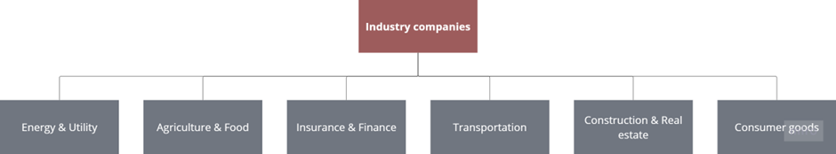

Figure 6 Indicative industry companies

### Customised categorisation

#### DestinE use case makers

DestinE Use case makers consist of organisations and initiatives that carry and implement a use case of the DestinE initiative, that may be related to the DESP, the Data Lake, or a Digital Twin. This stakeholder category includes several types of stakeholders. Some of them are presented in Figure 7 and may be analysed as follows:

* **Data providers**: Organisations that contribute data to the DESP, such as satellite imagery, weather data, and demographic data. They may be interested in using the platform to showcase their data and increase its visibility, as well as to gain insights from other data sources. Data providers may be concerned about the accuracy and quality of their data in relation to other data sources, as well as issues related to data privacy and security.
* **Model developers**: Organisations that develop models and simulations to be used in the DESP. They may be interested in using the platform to showcase their models and increase their visibility, as well as to collaborate with other model developers and data providers. Model developers may be concerned about the accuracy and quality of their models in relation to other models and data sources, as well as the potential for intellectual property issues.
* **Application developers**: Organisations that develop applications to be used with the DESP, such as visualisation tools and decision support systems. They may be interested in using the platform to showcase their applications and increase their visibility, as well as to collaborate with other application developers and data providers. Application developers may be concerned about issues related to data privacy and security, as well as the potential for competition from other application developers.
* **Infrastructure providers**: Infrastructure providers are organisations that provide hardware and software solutions to support the DESP, such as cloud computing services and data storage solutions. They may be interested in partnering with the DestinE initiative to provide infrastructure services, as well as to collaborate with other infrastructure providers and data providers. Infrastructure providers may be concerned about issues related to data privacy and security, infrastructure endurance, as well as the potential for competition from other infrastructure providers.
* **Policy advocates**: Policy advocates are organisations that advocate for policies related to the climate crisis and other environmental issues. They may be interested in using the data and insights generated by the DESP to inform their advocacy efforts, as well as to collaborate with other stakeholders to advance policy goals. Policy advocates may be concerned about issues related to data accessibility and the potential for the platform to be used to support policies that are contrary to their goals.
* **End-users**: End-users are organisations and individuals that use the DESP and its associated applications and tools to gain insights and make decisions related to climate crisis and other environmental issues. They may be interested in using the platform to access accurate and up-to-date information, as well as to collaborate with other stakeholders and share their own insights and data. End-users may be concerned about issues related to data privacy and security, as well as the usability and accessibility of the platform and its associated tools.

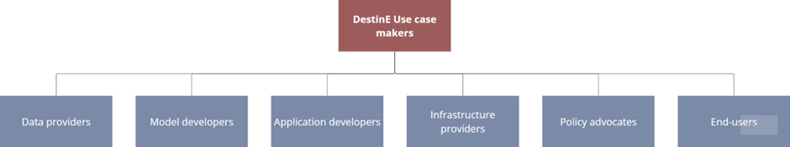

Figure 7 Indicative DestinE Use case makers

#### Core DestinE Entities

The organisations that form the Core DestinE Entities are key stakeholders involved in the funding, creation, implementation, and validation of Destination Earth. This includes the EC DGCNCT who is funding the project, the entrusted entities ESA, EUMETSAT and ECMWF, as well as all other organisations or projects that are involved in these first stages of DestinE.

#### General public

The general public may have a strong interest in the DestinE initiative as they may be interested in understanding the impacts of the climate crisis on their communities and the world at large, as well as identifying opportunities for adaptation and mitigation. They may also be interested in understanding how they can contribute to the initiative and its goals. Citizen scientists also can leverage DESP capabilities to support their projects and initiatives. General public including citizen scientists are considered DESP users and potential community members.

# DestinE Community Building Strategy development methodology

The development of the DestinE Community Building Strategy follows the basic principles of Strategic Planning as defined by many scholars in an international context (Miller and H-Jensen, 1997; Bryson and Einsweiler, 1988; Hopkins and Hopkins, 1997; Andersen, 2000 etc.) and applies the following methodological approach that shown in Figure 8.

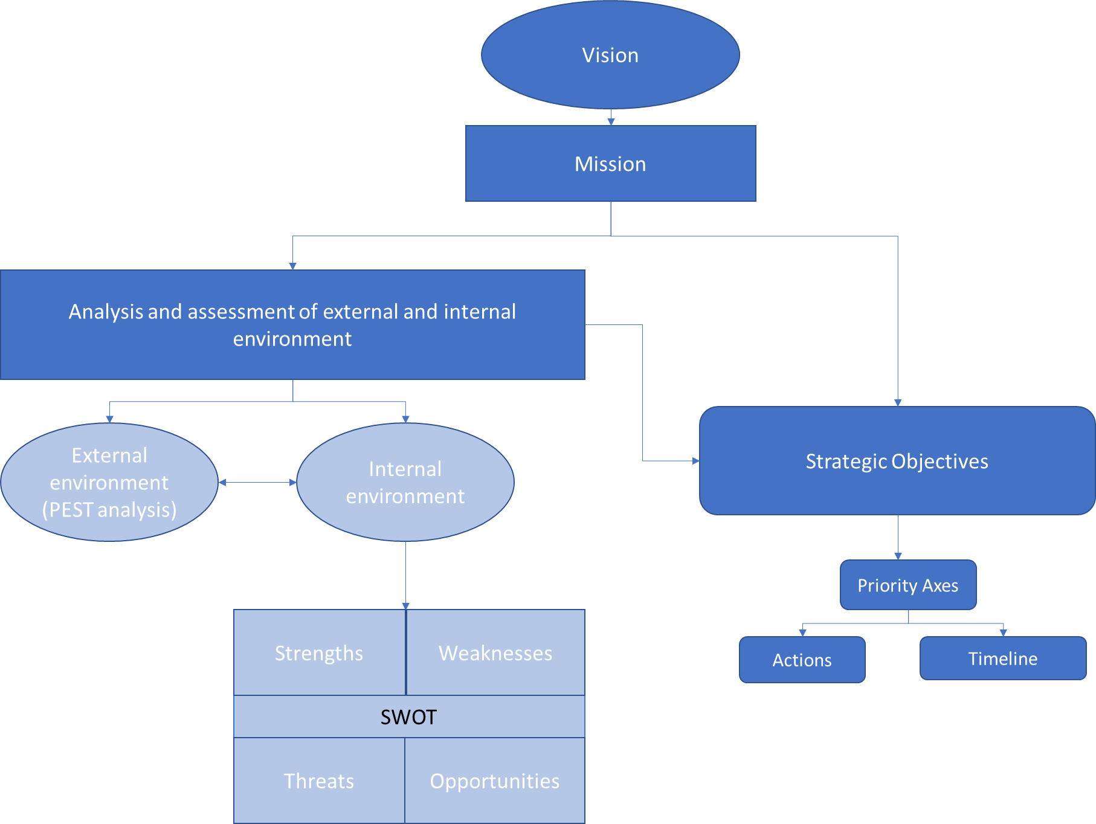

Figure 8: Methodological approach to the development of the Community Building and Management Strategy

Specifically, the steps in the development of the Strategic Plan include:

* Defining the vision and mission of the Community:

The first step in developing the Strategic Plan involves determining the guiding vision of the Community, which reflects the goals and values it seeks to achieve. Subsequently, the "Mission" of the Community is formulated, outlining the expected future state in accordance with the set vision.

* Analyzing and evaluating the current situation:

At this stage, the External Environment (PEST analysis) was explored, considering characteristics of the political, social and technological environment that can positively or negatively influence the development framework of the community. Information regarding the current internal environment of the community was then documented considering the characteristics and dynamics of the community that has been built so far and its further development. Subsequently, the analysis of the above information about the characteristics of the internal environment of the community fueled the application of SWOT analysis, aiming at the comprehensive exploration of the existing internal environment based on the identification of endogenous developmental characteristics and capabilities (strengths and weaknesses) compared to external influencing factors (opportunities and threats), respectively.

* Formulating Strategic Objectives, Priority fields, Actions:

At this stage, Short-Term Objectives (up to end of 2024) that require immediate achievement were set along with Medium - Term Strategic Objectives (up to end of 2026) and Long – Term Strategic Objectives (up to end of 2030). For each objective, priority axes, actions, and an implementation timeline were defined.

|  |
| --- |
| *The current Community Building and Management Strategy will serve as the main guide to support the effective development of DestinE Community and its way forward to sustainability. This is a living document which will be updated as required during the DEUC project.*  *It is a dynamic plan encompassing a series of strategic actions designed to grow the community. This strategic approach ensures adaptability to contemporary technological, scientific and initiative related advancements, along with meeting the escalating demands of end users and benefiting entities.* |

## Vision, Mission and Values

## **Vision**

|  |
| --- |
| As we embark on the journey towards 2030, DestinE envisions a thriving community, uniting passionate individuals and experts in a dynamic ecosystem. The DestinE’s community vision is to cultivate an unparalleled network where the synergy of continuous interactions among users, developers, and other stakeholders propels DestinE's evolution, contributing significantly to the advancement and continuous use of the DestinE Core Service Platform (DESP) and the Destination Earth System overall. |

## **Mission**

To advance towards the set Vision, the Strategy’s mission unfolds around four key pillars (Figure 9). The first pillar, "Unite," manifests as an aspiration to bring together all interested stakeholders and communities under a shared banner. Diversity and collaboration are considered, laying the foundation for a robust and inclusive community that transcends conventional boundaries.

The second pillar, "Engage," embodies the commitment to actively involve every member in the community. Through vibrant interactions, meaningful discussions, and collaborative efforts, DestinE community strives to create an environment where each voice is heard, valued, and actively contributes. The goal is to not only unite but to ensure that every united individual becomes an integral part of the community's fabric.

"Drive Usage and Growth," the third pillar, emphasizes the community's determination to increase the usage of DestinE's platform and services. User engagement takes center stage, empowering community members to actively participate in co-designing the platform and services evolution. This collaborative approach propels both the community and its offerings forward, fostering innovation and sustained growth.

The fourth and final pillar, "Sustain," underscores DestinE's commitment to creating a community that not only thrives but also sustains and grows itself. Through responsible practices, ethical decision-making, and a long-term vision, DestinE aims to be a beacon of sustainability in the digital landscape, ensuring the community's enduring impact.

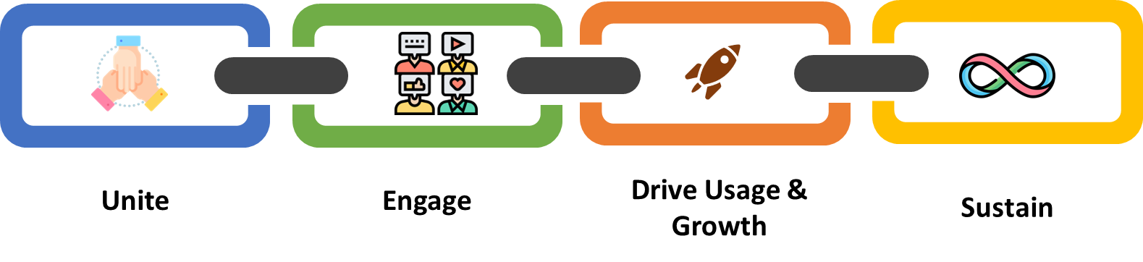

Figure 9: Strategy’s mission

## **Values**

Establishing values within a community is crucial as it helps to define the community's identity and purpose, fosters unity and cooperation, encourages accountability and responsibility, provides guidance for decision-making, and enhances its reputation and trustworthiness. Along these lines, DestinE Users Community aspires to integrate the following values:

* **Sense of belonging**: The sense of belonging is an important aspect of any community, and it provides a number of benefits to its members. Members of the DestinE Users Community should experience this sense of belonging and feel comfortable to share their thoughts, take an active role in the community and contribute to its success. Moreover, the members of the community should be able to excploit opportunities for social connection and develop meaningful collaborations and partnerships with others who share common or complementary interests and values. Finally, the sense of belonging can increase motivation to participate in community activities and achieve shared goals.
* **Co-design:** The active participation of DestinE Users Community members in the development and design of DESP is considered significant. Co-design in the DestinE Users Community aims to put users at the centre of the design process, ensuring that their needs, preferences, and feedback are collated and communicated effectively to the developers that oversee the final servicesThis will lead to more user-friendly, intuitive, and satisfying experiences. Being involved in co-design, members of the community will be able to experience a sense of ownership and investment in DESP evolution. It will also foster innovation and creativity by bringing together diverse perspectives and ideas. This can lead to novel solutions and approaches that might not have been possible with a more limited, top-down design approach.
* **Openness and transparency:** Openness and transparency are considered to be amongst the core values that the Destine Users Community aims to embrace. It is crucial to foster open communication and build trust among members. Members should be encouraged to share information and insights about their experiences, knowledge on a topic, and challenges with one another. Open and accessible channels for communication should be provided so as members can share their thoughts and ideas, ask questions, and get involved in discussions. Access to information, such as documentation, product roadmaps, and development plans, should be provided. When users provide feedback or raise concerns, it's important to be responsive and transparent about how their feedback is being used. Regularly sharing updates about the progress of activities, features, or services should be enforced to build trust and demonstrate a commitment to transparency. It is also important that members are able to see how decisions are being made and how their feedback is being incorporated.
* **Diversity:** The DestinE Users Community aims to be welcoming and inclusive to individuals from diverse backgrounds, experiences, identities, and gender. To promote diversity and equality within the community, a code of conduct will be defined and made easily accessible to all members of the community and prohibit any form of discrimination and harassment. To encourage diversity and inclusivity in the community, members from different backgrounds and perspectives will be invited to join by promoting the community through various channels and ensuring that outreach efforts are inclusive. It is also important to foster an environment of mutual respect and support by encouraging members to listen to and learn from each other, as well as provide opportunities for members to participate and contribute to the community regardless of their diverse backgrounds, geographical or other differences. Additionally, the usage of gender inclusive language will be strongly promoted both in the discussions and activities (physical and virtual) and in the outreach and communication material. Moreover, it is significant to integrate inclusivity throughout the activities of user requirements and feedback collection to ensure that intersectional and diversity analyses are being mainstreamed into the design of DESP services.
* **Equity:** All members within the DestinE Users Community should have access to the same resources and opportunities for participation and engagement regardless of their background, identity, or socio-economic status, giving priority to stakeholders from EU Member States. Training and skill-building opportunities to members of the community who may face barriers to participation should also be considered as well as engagement in outreach and recruitment efforts to attract members from underrepresented or marginalised groups including targeted advertising that reach out to diverse communities.
* **Sustainability:** DestinE Users Community should be sustainable and grow and evolve over time throughout DestinE initiative implementation and beyond. This requires creating a strong sense of community, ownership and fostering relationships between members. It requires also to empower community leaders to take ownership of the community and to continuously encourage community members to share their experiences and ideas through user-generated content. Collaboration among community members to foster relationships and create a sense of shared purpose should also be encouraged. Ultimately, a common online place for communication should be established and tools and guidelines for community management and uptake should be provided.

## Analysis and evaluation of the external and internal environment of the community

## **External environment (PEST analysis)**

**Political:**

The political landscape, particularly driven by initiatives like the European Green Deal, provides a favorable environment for the development of a digital twin of the Earth. The commitment to climate neutrality and sustainable economic growth enhances the initiative's relevance and support. The alignment with Digital Strategy priorities further ensures that political backing facilitates transparency, accountability, and collaborative efforts between the public and private sectors, fostering an environment conducive to the initiative's success.

**Economic:**

The economic factors, shaped by recent crises such as the Covid-19 outbreak and geopolitical tensions, present both challenges and opportunities for the initiative. Economic uncertainties highlight the importance of the digital twin's role in providing a tool for modeling and simulating natural hazards, aiding in economic resilience. The initiative's success will be influenced by its ability to address economic concerns related to environmental uncertainties and contribute to stability through accurate adaptation strategies and mitigation measures.

**Social:**

The social fabric characterized by diversity and pluralism in Europe influences the initiative's development and adoption. EU policies on digital transformation and the reduction of social inequalities align positively with the initiative's goals. However, the challenge lies in managing the abundance of information accessible to EU citizens. The initiative's effectiveness will be influenced by its capacity to bridge the gap between information abundance and societal needs, particularly in the context of social dynamics and responses to natural disasters.

**Technological:**

Technological factors play a pivotal role in shaping the initiative's trajectory. Community contribution through voluntary data sharing is crucial for enhancing data quality, accuracy, and interoperability. While advanced technologies like AI offer opportunities, the initiative must navigate associated risks in cybersecurity and data protection. Compliance with EU legal frameworks ensures responsible technological integration. The initiative's success is contingent on its ability to adapt and leverage evolving technologies within the defined regulatory landscape, ensuring a secure and technologically robust digital twin.

## **Internal environment (SWOT analysis)**

|  |  |
| --- | --- |
| **Strengths** | **Weaknesses** |
| * Rising number of interested members (>1300 registered members already). * Diversity of members - it brings together a variety of perspectives and experiences that can be used to solve problems and innovate. * Current members are active and engaged in the community. * Regular physical meetup in place (User eXchange events). * Networking, collaboration and knowledge transfer with initiatives or communities of similar caliber (eg. Copernicus). * Diverse Use Cases are being developed bringing their communities onboard. | * DestinE is not very well known outside of its immediate community. This lack of awareness makes it difficult to attract new members of all potential groups of users. * No dedicated social media in place. * Lack of a common online “place” where community members and/or users can interact. * Currently limited exposure of what the platform could be, to end users. |
| **Threats** | **Opportunities** |
| * Delays in making DestinE components available to the community. * Large number of user base making the congregation of the entire community in real life challenging. * The decentralized nature of the community could lead to fragmentation and siloed efforts, hindering collaboration and collective impact. * Maintaining the community's open and collaborative nature. | * Promote codesign mentality as a community umbrella. * Partnerships or collaborations with other existing communities or initiatives. * Technological advancements to leverage new technologies or tools to enhance community engagement. * Funding opportunities for new projects and collaborations under the DestinE umbrella raise awareness and engagement about the community. |

## Strategic Objectives

|  |
| --- |
| **Short – Term Objectives (2024)** |
| STO1 – Community Members base expansion to 3K by the end of 2024 |
| STO2 – Enforce user interaction with DESP platform – reach 1K registrations by the end of 2024 |
| STO3 – Develop and set a co-design framework within the community |
| **Medium – Term Objectives (2026)** |
| MTO1 – Community members and DESP user base expansion to 10K by the end of 2026 |
| MTO2 – Community members, CoPs and DESP user interactions takes place within the DESP platform |
| MTO3 – Existing CoPs to increase their membership and operate independently and new CoPs to be naturally formed around topics of significant interest |
| MTO4 – Establishment of a user-driven recommendations and requirements protocol for seamless communication and interaction with DESP and DestinE developers. |
| **Long – Term Objectives (2030)** |
| LTO1 – Community members and DESP user base expansion to 50K by the end of 2030 |
| LTO2 – Community grows organically and is self-sustained |
| LTO3 – Community and user needs are translated into targeted DESP features and services enhancements via officially established protocols |

|  |
| --- |
| *Note: The current version of this document presents priority axes and actions for the short-term objectives (2024).* |

## Short-Term Objectives – 2024

Embarking on the journey to establish a thriving DESP by 2030, our strategic approach involves meticulous planning and the early cultivation of a vibrant community. Recognising the significance of community engagement in shaping the success of the platform and the initiative in general, we aim to lay the groundwork well before the initial launch – foreseen for 2024. To achieve this, a set of short-term objectives are outlined that focus on community-building initiatives and community members engagement to create a robust foundation for DESP’s launch but also laying the groundwork for a sustained, interactive, and supportive community that will propel our success well into the future.

**STO1 - Community Members base expansion to 3K by the end of 2024**

Presently, the community stands at a membership of 1,300+ registered individuals, symbolizing a community united by a shared commitment to fully exploit and advance DESP and DestinE.

As we conclude the year 2024, we aspire to achieve significant growth, targeting 3,000 registered members within the DestinE community, assuming that there will be means to centralise data collection between the DestinE website (where the community is gathered) and the DESP (which would most likely be the first entry point for registering DestinE users). This numerical ambition is an estimation of our commitment to fostering a diverse and engaged community dedicated to advancing the DESP.

To achieve this strategic objective the following Priority Axes and actions are set.

**Priority Axis – PA1.1: DEUC Communities of Practice enabled**

Communities of Practice (CoPs) are groups of people who share a common interest, concern, or passion and come together to learn from each other, solve problems and address challenges. CoPs can provide a place for individuals to:

* Share their knowledge, experience, and expertise with each other.
* Innovate and generate new ideas.
* Co-design, validate and promote products and strategies.
* Discuss and address common challenges together.
* Network and build relationships with others in their field, which can lead to new opportunities and collaborations.

In the context of the DEUC project, CoPs will be used to:

* Identify DESP user needs and preferences. By engaging with users through a CoP, it will be possible to get feedback on what features or functions are most important to them.
* Tap into the knowledge and expertise of individuals from different fields or industries. This can help the development of DESP that will meet the needs of a wide range of users.
* Test and validate the developed features and functionalities with the end users – which according to the feedback solicited can be refined to meet the user needs.
* Foster collaboration between individuals with different backgrounds and perspectives. This can lead to new ideas and approaches to DESP development.
* Support adoption and uptake of DESP.

This way, the needs and recommendations of different user groups will be better understood ensuring that the development of DESP is guided by the specific needs of the users, leading to more effective and impactful solutions. Moreover, the creation of CoPs will help to promote the wide adoption of DESP, as members of the CoPs become ambassadors for the platform within their respective communities.

In addition, CoPs can be exploited in the context of the work and projects carried out by the three Entrusted Entities (3Es): ESA, ECMWF and EUMETSAT in terms of joint participation in events, usage of CoPs activities to generate insights for 3Es’ work, organisation of joint events where all communities can work together etc.

**CoPs – Organic creation approach**

Recognising the existence of various communities already in fields related to DestinE initiative, our approach is to harness their potential and build upon their foundations.

By tapping into established networks, expertise, and shared interests, we harness the collective potential of these communities to drive the formation of specialized CoPs. This organic formation of vibrant and self-sustaining CoPs ensures relevance, engagement, and collaboration while capitalising on the knowledge and relationships already present. By adopting this strategy, DestinE will create a strong foundation for the development of CoPs, enabling knowledge sharing, collaboration, and innovation to flourish.

Established communities often comprise individuals with significant expertise and experience in specific areas. By integrating these communities, we gain access to their collective knowledge, which can serve as a strong foundation for the formation of specialised CoPs. This approach ensures that CoPs are established with a solid knowledge base and have access to subject matter experts who can guide and mentor community members.

Moreover, leveraging existing communities helps ensure that CoPs are aligned with the interests and needs of participants. By involving community members in the formation process, we can leverage their input and feedback to shape the focus and direction of CoPs. This participatory approach increases the relevance of CoPs and encourages active engagement and contribution from community members.

In addition, the Use Cases to be procured within the DEUC project can lead to the creation of new CoPs covering various thematic perspectives related to the Green Deal and Digital Transformation.

Taking into consideration the two Digital Twins that are being developed, each CoP, will be discussing and holding activities that involve discussions regarding their themes in relation to Weather Extremes and Climate Change Adaptation. Within these, there will be a validation of existing DESP capabilities, as well as discussions on the design of future DESP capabilities (*Figure 3*).

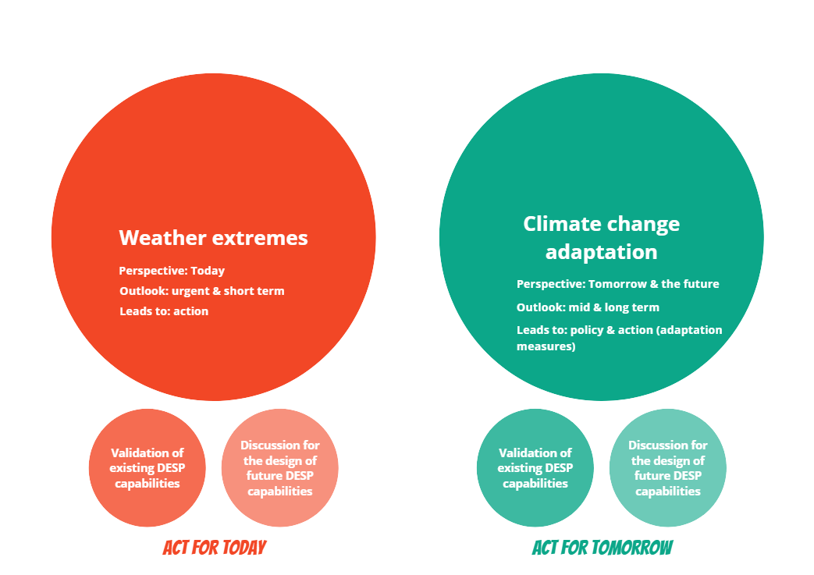

*Figure 3: Areas that CoPs activities may focus*

**CoPs set-up, operation and governance**

As DestinE is an ongoing endeavour, CoPs need to be inaugurated and commence their interactions before they develop and flourish into thriving hubs, centred around member interactions, offering opportunities for co-development.

Activities in 2024 focus on establishing the first set of CoPs. These may evolve from existing communities or emerge as new groups. Key activities during this phase include:

* **Onboarding Initial Members**: Recruiting participants who are passionate about contributing to the DestinE project through the Digital Earth Science Platform (DESP).
* **Developing a Collaborative Framework**: This framework will foster co-design with end users, emphasizing the importance of listening, empathy, and understanding diverse perspectives and needs.
* **Building a Foundation for Future Growth**: By slowly expanding the member base and activities, these CoPs will gradually contribute insights and recommendations to the DestinE project through DESP.

The operation of CoPs shall be supported by a governance model which has to be flexible and adaptable to the community's changing needs and circumstances as well as transparent and inclusive, ensuring that all members have a say in the community's activities. In the context of DEUC project each CoP may be led by a Community Facilitator, who will be responsible for facilitating communication and collaboration within the group. In case of existing communities, the Community Facilitator from DEUC project side will be responsible for facilitating communication and collaboration regarding DESP activities in accordance with the rules of each existing community and in consultation with the leader of that community.

Members of the CoPs can be passive or active. A passive member can follow updates about DestinE activities and outputs. An active member can participate in the activities (co-design, user recommendations collection, hackathons, etc.), use and test DestinE services, propose topics of interest, share content and relevant work, as well as have access to a range of resources and tools, including webinars, online discussion forums, and training materials.

At the current stage of the DEUC project, anyone who is interested in applying for becoming a member of DestinE community can apply online via a dedicated form in the website (<https://destination-earth.eu/destine-community/become-part-of-the-destine-community/>).

CoPs are designed to function both physically and online. Physical operation of CoPs will take place via the organisation or participation in physical events. Online operation during 2024 will take place via online meetings (see PA1.3).

|  |  |
| --- | --- |
| **Actions** | **Timetable** |
| A1.1.1 Map, connect and collaborate with existing communities and initiatives (at least 3 synergies with existing communities). | 2024 |
| A1.1.2 Set-up of at least 2 CoPs leveraging also the DEUC project’s Use Cases communities to be formed. | 2024 |
| A1.1.3 Develop a CoP governance framework. | 2024 |
| A1.1.4 Implementation of CoPs events and meetings (linked with PA1.2). | 2024 |
| A1.1.5 Establish structured feedback mechanisms to gather insights on the effectiveness of CoP activities. Use feedback to continuously refine and enhance the CoP experience. | 2024 |

**Priority Axis – PA1.2: Community engagement via organization of events and activities**

To enhance community engagement and foster growth, PA1.2 focus on organizing events and activities to create a vibrant and interactive environment. The aims is to host regular events tailored to the interests and needs of the community members to significantly boost participation and cultivate a sense of belonging. These events could range from webinars, workshops, to virtual social gatherings or collaborative projects. Additionally, incorporating interactive elements within events, such as Q&A sessions, polls, and networking opportunities, will ensure that community members actively contribute and feel valued. Leveraging various communication channels, including social media, newsletters, and dedicated event platforms, will amplify the reach and accessibility of the community events. Encouraging user-generated content or facilitating member-led sessions will also further empower the community. Ultimately, a well-curated calendar of events will be developed to enhance community engagement by providing meaningful and enjoyable experiences, creating a dynamic ecosystem that attracts new members and retains existing ones.

|  |  |
| --- | --- |
| **Actions** | **Timetable** |
| A1.4.1 Online events planning and content development (at least 6). | 2024 |
| A1.4.2 Organization of 1 physical community event. | 2024 |
| A1.4.3 Utilization of various communication channels, such as newsletters, social media, relevant websites, to announce upcoming events. | 2024 |
| A.1.4.4 Use of DestinE website or DESP to document key insights of the community activities. | 2024 |
| A.1.4.5 Conduct surveys or polls or post event follow-up to gauge community interests and preferences, ensuring event themes resonate with members | 2024 |

***An indicative plan of the Actions A.1.4.1 and A1.4.2 is presented below:***

|  |  |
| --- | --- |
| **Activity 1** | **Introduction to the DestinE Community** |
| Date | February 2024 |
| Duration | 2 hours |
| Meeting Lead | AUTh |
| Audience | Community members |
| Type | Seminar |
| Mode | Online |
| Description | This initial meeting is an opening of the interactions to the community as it has developed to the day. Participants will be informed of   * the DestinE Community Vision, * what the current state of the community is, * the Community Building Strategy * how the community is expected to work * the Communities of Practice (CoP) and * how they can and will be involved |
| Material to prepare | Presentations for plenary |
| Actions post-event | Share upcoming CoP events, including brief description of each |

|  |  |
| --- | --- |
| **Activity 2** | **1st individual Community of Practice (CoP) meeting** |
| Date | March 2024 |
| Duration | 1,5-2 hours |
| Meeting Lead | CoP Lead - AUTh |
| Audience | CoP interested community members |
| Type | Seminar + Discussion session |
| Mode | Online |
| Description | Per CoP, DestinE community members approach this meeting in order to be informed:   * on the interests of the CoP * on the CoP members and * of existing Use Cases already of interest for the CoP   Additionally, in the discussion session, through interactive means, CoP community members will be given the opportunity to voice their thoughts live in regards to:   * specific themes of interest, they would like the CoP to engage with * share projects and Use Cases which could be presented and showcased within a next CoP meeting * questions that still remain, regarding DestinE * present themselves to the CoP, as to their interest, affiliation and aspirations of being part of the CoP * how they actively work without DestinE & how they imagine working WITH DestinE. |
| Material | Presentation for CoP plenary  Slido questionnaire |
| Actions post-event | Analysis of slido responses to gather recommendations on   * DESP system * Community activities * Member Hopes & opportunities |

|  |  |
| --- | --- |
| **Activity 3** | **2nd individual Community of Practice (CoP) meeting** |
| Date | April 2024 |
| Duration | 1,5-2 hours |
| Meeting Lead | CoP Lead - AUTh |
| Audience | CoP interested community members |
| Type | FireSide Chat with existing DestinE Use Case + Networking |
| Mode | Online |
| Description | CoP members are given the opportunity to interact with individuals from existing Use Cases on DestinE. Following an initial presentation of the Use Case, a fireside chat can help open up themes of interest for the CoP.   * why is this Use Case relevant, * what is the experience of developing the Use Case, * how it is to develop it within DESP and DestinE * what opportunities and new thoughts have developed as being part of DestinE * what have been the main challenges, and how have they been addressed, if not yet overcome? * inside tips, good practices and things to avoid when working within such a framework |
| Material | Discussion themes for Fireside Chat  List of prevocational question to be shared live on the chat, during the event, in order to invite responses by the audience.  Slido questionnaire & live Q&A |
| Actions post-event | Analysis of discussion to gather user recommendations on   * DESP system * Community activities * Member Needs & Sceptiscism (thoughts) |

|  |  |
| --- | --- |
| **Activities 4-5-6** | **3rd - 4th - 5th individual Community of Practice (CoP) meeting** |
| Date | May, June, July 2024 |
| Duration | 1,5-2 hours |
| Meeting Lead | CoP Lead - AUTh |
| Audience | CoP interested community members |
| Type | Seminar in response to CoP members themes + Networking |
| Mode | Online |
| Description | An initial presentation and discussion will be organized based on the CoP community members themes of interest expressed in the 1st CoP meeting (March 2024). This will be researched, shared and developed by the CoP Lead. |
| Material | Presentation for CoP plenary  Slido questionnaire |
| Actions post-event | Analysis of discussion to gather user recommendations on   * DESP system * Community activities * Member Needs & Sceptiscism (thoughts) |

***DestinE Hackathons***

|  |  |
| --- | --- |
| **Activity A** | **Envisioning the Impact of DestinE Challenge** |
| Launch Date | ±20 March 2024 |
| Duration | 20 March – 20 April 2024 |
| Audience | DestinE community members |
| Type | Open Call for Ideas |
| Mode | Online |
| Description | Given the great impact of DesinE to everyday life, participants of this Challenge will be given the opportunity to ideate solutions and almost fictional services that could be offered by DESP. Spread over the duration of 3 month, participants will be part of a number of activites. Indicatively:   * **20th March:** participants will be part of the Open Call launching evening – where information on DestinE, DESP and DT engines will be shared by the 3E entities   The challenge will be shared & Q&As discussed   * **5th April:** An interim online feedback section may be hosted * **20th April:** Submission of final proposals * **10th May:** Participants informed of results, * **25th May:** Invitation to attend online event of winners presenting their concept in the form of pitches. **Attentively:** This could be the 4th Community Event including all CoPs concurrently (June 2024 – see step 5 in Monthly Events, above) |
| Material | Presentations from ESA, EUMETSAT & ECMWF, DESP team  Slido questionnaire |
| Actions post-event | Analysis of discussion to gather user recommendations on   * DESP system * Community activities * Member Needs & Opportunities |

|  |  |
| --- | --- |
| **Activity B** | **In Real Life Hackathon (*depending on DESP availability)** |
| Launch Date | Mid July 2024 |
| Duration | 3 Days |
| Audience | DestinE community members |
| Type | Hackathon |
| Mode | In Person / Thessaloniki |
| Description | In the duration of 3 days, community members will be invited to Thessaloniki interact with an early version of the DESP platform in DestinE. |
| Material | Presentations from ESA, EUMETSAT & ECMWF, DESP team  Slido questionnaire |
| Actions post-event | Analysis of discussion to gather user recommendations on   * DESP system * Community activities * Member Needs & Opportunities |

**Timeline of Activities**

|  |  |  |  |  |  |  |  |  |  |
| --- | --- | --- | --- | --- | --- | --- | --- | --- | --- |
| **Activity** | **Jan** | **Feb** | **Mar** | **Apr** | **May** | **Jun** | **Jul** | **Aug** | **Sept** |
| 1 |  |  |  |  |  |  |  |  |  |
| 2 |  |  |  |  |  |  |  |  |  |
| **A** |  |  |  |  |  |  |  |  |  |
| 3 |  |  |  |  |  |  |  |  |  |
| 4 |  |  |  |  |  |  |  |  |  |
| 5 |  |  |  |  |  |  |  |  |  |
| 6 |  |  |  |  |  |  |  |  |  |
| **B** |  |  |  |  |  |  |  |  |  |

**Priority Axis – PA1.3: Dissemination and communication**

The priority axis of "Dissemination and Communication" is pivotal in achieving the ambitious goal of reaching 3,000 members within one year. This focus underscores the significance of effectively conveying the community's mission, values, and offerings to a broader audience. Through targeted dissemination, the community can extend its reach, attracting individuals who align with its vision and creating awareness among potential stakeholders. Communication plays a key role in articulating the unique value proposition of the community, emphasizing the benefits of membership, and showcasing the vibrant ecosystem it offers.

An effective dissemination and communication strategy has been put in place already which involves leveraging diverse channels to engage with potential members. Regular and compelling content creation, such as blog posts, articles, and infographics showcase the community and foster interest. Establishing partnerships, both online and offline, can also amplify the dissemination efforts, tapping into existing networks and increasing visibility. Ultimately, by strategically disseminating information and maintaining clear and consistent communication, the community can catalyze interest, draw in new members, and achieve the targeted goal of 3,000 members within the stipulated timeframe.

A Communication and Engagement plan has been put in place since 2023 and is detailed in Chapter 4 of the current document.

|  |  |
| --- | --- |
| **Actions** | **Timetable** |
| A1.3.1 Development and update of a Communication and Engagement plan. | 2023 & 2024 |
| A1.3.2 Regularly share engaging content, including community updates and upcoming events, to maintain an active and visible presence. | 2023 & 2024 |
| A1.3.3 Actively participate in relevant online forums and discussion groups and events/conferences to introduce the community to new audiences. | 2023 & 2024 |
| A1.3.4 Monitor and track performance of the activities. | 2023 & 2024 |

**STO2 - Enforce user interaction with DESP platform – reach 1K registrations by the end of 2024**

The year 2024 will witness the pivotal launch of the DESP. This event is a seminal moment, as our community transitions into a digital realm, providing a curated space for collaboration, connection, and the amalgamation of knowledge. By mid-2024, it is expected that user registration on the DESP will be enabled. This step represents an intentional effort to broaden our community's reach, inviting individuals to use and interact with the platform. The goal is set to reach 1K registrations to DESP platform by the end of 2024. It is not only about the platform's introduction but onboarding community members as DESP registered users.

To achieve this strategic objective the following Priority Axes and actions are set.

**Priority Axis – PA2.1: Community members become DESP registered users**

|  |  |
| --- | --- |
| **Actions** | **Timetable** |
| A2.1.1 Develop a structured onboarding material to guide community members through the process of becoming DESP registered users. | 2024 |
| A2.1.2 Provide step-by-step tutorials, documentation, and support to ensure a seamless transition onto the platform. | 2024 |
| A2.1.3 Foster MOOCs uptake to familiarize members and users with DESP features and functionalities (linked to PA2.2). | 2024 |

**Priority Axis – PA2.2: MOOCs development and promotion**

|  |  |
| --- | --- |
| **Actions** | **Timetable** |
| A2.2.1 Develop MOOCs related to DESP platform functionalities. | 2024 |
| A2.2.2 Develop MOOCs related to the DEUC project use cases to increase interaction. | 2024 |
| A2.2.3 Implementation of a feedback loop to ensure learners feel supported and connected to the learning process. | 2024 |

**STO3 - Develop and set a co-design framework within the community**

The approach of co-design keeps the individuals involved in any way in DestinE, close to its centre. These individuals, irrespective of their technical skills, bring to the table their personal expertise in their line of work, which is crucial for the holistic development and approach for DestinE. From policy makers and first responders in climate change events who may share views on what kind of information is most important to view in case of emergencies and in what format, to research and academia personnel who can share how they may use the available data to conduct their research, and to developers of new products and services who wish to explore how to elevate available datasets into useful proposals and use cases, co-design is an approach that requires openness, acceptance of various views, transparency and a democratic mindset.

Though codesign can involve various depths of involvement of users in the design process, from simply inviting the sharing views, to citizen science and user generated decision making, the aforementioned users and stakeholders involved in various ways, by sharing views and recommendations with DESP developers, in regard to their needs and day-today problems. Following, DESP developers can prioritize and address whether these recommendations can become parts, capabilities, or features of the core DESP service, as it is being developed. However, it must be clear that the final decision making on which recommendation is implemented and to what extent, currently remains with the DESP developers, since they maintain a bird’s eye view of the entire development process.

Users and stakeholders share their input in this co-design process through organized and curated activities and tools, such as “User Stories”, sharing how they operate today and how they might operate in the future with the presence of DesitnE, “User Journey Maps”, sharing their activities and detailed steps of how they operate day to day, “Card Sorting”, sharing their preferences among preselected choices on specifically asked questions, taking part in to Q&As in Community of Practice (CoP) discussion sessions, responding to questionnaires as part of the CoP activities and casually exchanging views and viewpoints during the community’s networking activities.

Additionally, given the activity of existing communities of the 3Es, the DestinE community aims to reach out, involve and liase with these communities in its planned activities, as the project goal is universal and mutually beneficial. Within these activities, DESP developers are involved directly or indirectly in the interactions between community members and once each is completed, developers will be informed of the output and key interaction points through community feedback loops in post-event actions.

|  |  |  |  |  |
| --- | --- | --- | --- | --- |
| **Co-design within DestinE** | | | | |
| **Codesign input level** | **1** | **2** | **3** |
| **Codesign input** | **Sharing views** | **Providing suggestions** | **Collaboration and Design** |
| **User involvement** | Inviting views from the community in order to gain an understanding of their reality | Inviting informed opinions from the community on set subjects. | Informed and curated recommendations about the DESP features and functionalities. |
| **DESP developer engagement** | No commitment to take these input onboard by the DESP development team | Attention paid, but no commitment to take these onboard by the DESP development team | Feedback is given by DESP development team and actively working to make suggestions fit for the platform. |
| **Co-design activities** | Community activities, Ideation challenges | CoP Activities,  Hackathons | Recommendations formulation |

The identification of users and their engagement may follow the successful example of “climate services coproduction processes”[1] i.e.:

a. Step 1: Establish the Why - High-Level Goal Conceptualization: To begin by focusing on the overarching goal or issue before diving into specifics. To consider high-level goals that may involve policy changes, attitude shifts, new collaborations, or empowerment.

b. Step 2: Identify the Where - Defining the Case: To define the specific context, recognizing the complexity of interconnected systems and various levels of influence.

c. Step 3: Determine Whom to Include - Stakeholder and User Identification: To identify stakeholders and users based on their relevance to the high-level goal. Consider participatory methodologies to dispel initial assumptions and ensure mutual learning.

d. Step 4: Select Which Attributes - From Stakeholders to Users: Το characterize stakeholders based on attributes like influence, power, and legitimacy. Determine their role in the coproduction process based on factors such as urgency, legitimacy, and knowledge types.

e. Step 5: Define Engagement Intensity: To determine the degree of involvement in the coproduction process based on attributes identified in Step 4. Tailor engagement intensity from awareness raising for all stakeholders to involvement for potential users and empowerment for final users.

**Priority Axis – PA3.1: Establish a co-design approach in community activities**

|  |  |
| --- | --- |
| **Actions** | **Timetable** |
| A3.1.1 Develop clear and concise guidelines that outline the principles and processes of co-design within the community. | 2024 |
| A3.1.2 Identify specific activities, features, or initiatives within the community that are suitable for co-design (linked with PA1.2) | 2024 |
| A3.1.3 Establish a process for recognizing and showcasing members' contributions to co-design activities. | 2024 |

**Priority Axis – PA3.2: Effectively communicate the community co-design results to DESP developers**

The establishment of a robust communication channel, where community recommendations are conveyed to DESP developers, directly influencing the trajectory of feature development is crucial for the community to fulfil its existence and role while ensuring that the platform is finely tuned to the evolving needs and aspirations of its user base.

|  |  |
| --- | --- |
| **Actions** | **Timetable** |
| A3.2.1 Establish a User-Feedback Approach/Protocol. | 2024 |
| A3.2.2 Provide an online place for users to share recommendations, insights, and experiences which will be shared with the DESP development team. | 2024 |
| A3.2.3 Provide regular updates on how user feedback is being processed, implemented, and contributing to platform enhancements. | 2024 |

# DestinE Communication and Engagement Plan

This **Communication and Engagement Plan** is drawn up as part of the DEUC project which includes in its obligations not only to deliver use cases but also to contribute to the promotion of DestinE. As other entities are expected to carry out their own promotional activities for DestinE such as the European Commission, the three Entrusted Entities and their respective contractors, this Communication Plan’s scope is limited to the following:

* Promotional activities for DestinE (in consultation and conjunction with the other EEs and the EC).
* Operation of the Joint DestinE Website (formerly the DestinE Community Portal, expanded in scope).
* Support for the implementation of the CBMS.
* Support for the activities foreseen as part of the DestinE Use Cases project (DEUC).

This communication plan does not cover the activities carried out by the EEs and the EC independently from DEUC.

The plan contributes to the first phase of the Destination Earth initiative (the initial implementation phase). Priority will be to communicate widely to build general interest on the initiative, building a solid basis that can be exploited later when the activities related to DestinE will be further developed. The main emphasis of this Communication Plan is on European and Associated Countries and will be implemented from February 2023 until July 2024.

## Communication and Engagement Objectives

The high-level communication objectives are the following:

1. Provide communication support to the Destination Earth Use Cases (DEUC) project activities namely:
   1. **Community Building**: Foster the active engagement and participation of DestinE user communities in the co-design, development, co-evolution and use of DestinE capabilities, applications and solutions.
   2. **DESP Recommendations Gathering**: Gather the stakeholders’ needs and requirements and encourage their direct involvement and guidance in the continuous evolution of the DestinE infrastructure and capabilities towards the future Phases of the Initiative.
   3. **Use Cases Procurement and Promotion**: Demonstrate the ability of the DestinE infrastructure in general through a first set of use cases.
2. **Promote Destination Earth**, specifically:
   1. Raise awareness about environmental phenomena and the effects of climate change in general together with possible mitigation and adaptation options in an easily understandable format for all.
   2. Increase the visibility of concrete actions undertaken by the EU to achieve the objectives of the twin transition (green and digital) in line with the major strategies of the EU (the Green Deal, the Digital Strategy).
   3. Highlight the transversal role of digital technologies to achieve EU’s climate objectives and in helping Europe to become the world's first climate-neutral continent by 2050 (the 2030 Climate Target Plan).
   4. Highlight the crucial role of EU’s new HPC and AI capabilities in implementing DestinE and its objectives in environmental/climate modelling and predictions.
   5. Highlight the key role of the past, present, and future investments in European Earth observation and other related EU programmes for predictions and accountable knowledge, based on European technological and scientific excellence.
   6. Demonstrate European industry's strong competitiveness in the development of advanced technologies for delivering the technology needed for DestinE.

## Resources

### DestinE Joint Website Editorial Board

The Editorial Board oversees and has the ultimate decision-making on what will be published on the website. It consists of the following roles.

Table 3 Editorial Board

|  |  |  |
| --- | --- | --- |
| **Role** | **Description** | **Key Figures** |
| **Content Editors** | The content editors will oversee the entire process, from content planning to ensuring content is published on time and up-to-standard. | Lead Content Editor: Rob Carrillo (Trust-IT)  Deputy Content Editor: Zachary Smith (Trust-IT) |
| **Content Strategists** | At least one from each entrusted entity, will assist the editor with content planning, check content policies and ensure compliance. | Claudia Vitolo (ESA)  Gaia Maggi (ESA)  Neil Fletcher (EUMETSAT)  Danaële Puechmaille (EUMETSAT)  Sophia Sheridan (ECMWF)  Rafael Cereda (ECMWF)  Jolanda Patruno (Starion Group) |
| **Advisor** | The advisor will be from DG-CNECT and will ensure that content complies with the EC policies and vision. | Advisor: TBC (EC)  Backup: Stephan Siemen (EC) |

*4.2.2 Content Production Team*

The content production team is tasked with implementing the strategy as indicated in the communications plan and the directions of the DestinE Editorial Board.

Table 4 Content Production Team

|  |  |  |
| --- | --- | --- |
| **Copywriters, Video production, events specialists** | Content creators are asked to develop the content. These are mainly selected amongst EEs’ contractors. | Luigi Colucci (Trust-IT)  Valeriya Fetisova (Trust-IT)  Fabiana De Carlo (Trust-IT)  Marialetizia Mari (Trust-IT)  Sara Pittonet Gaiarin (Trust-IT)  Diego Simoni (Trust-IT)  Diego Domenici (Trust-IT)  Joanne Ahern (Trust-IT) |
| **Graphic and web designers** | Carries out the technical development of the DestinE Joint Website. | Alessandro Petrocelli (Trust-IT)  Luca Di Fiore (Trust-IT)  Riccardo Giuntini (Trust-IT)  Christian Attanasio (Trust-IT)  Lorenzo Calamai (Trust-IT) |
| **Subject Matter Experts** | Subject matter experts are asked to support content creators and validate content from a scientific and technological point of view. These are mainly selected amongst the 3Es and/or amongst community experts on an ad hoc basis. | To be sourced ad-hoc |

### Editorial process

The editorial process is the process by which the editorial board creates, develops, approves and publishes content. The editorial process uses Jira to control the editorial and approval workflow, which is complemented by a monthly conference call to discuss any issues or needed adjustments to the process and strategy. The editorial process follows the following steps:

**Step 1 - Content Request**: Any editorial board member can create a request for content to be published or modified on the website. This is done simply by creating an “issue” on Jira, and filling in the following important information:

* Type of content - Blog/Event/News, New Webpage/Section, New Website Feature or Website Error/Bug)
* A summary - short title which briefly explains the request)
* Description - a detailed explanation of what is required, including attachments, images or links to make the task as clear and easy as possible
* Entrusted Entity/s - which EE/s is the content related to. This is important both to track published content for balance and to know who will need to approve the content before publishing
* Needs EC Approval - this must be checked if the content is of a political nature (including policy, budget etc.)
* Priority - how important this is
* Due Date - When this content should be published
* Start Date - When this content should be started (this can be useful when you still need to add more information before the work can start)

Once created, the issue will appear with the “To do” status on Jira. The Content Editors will check every new issue and assign them to Content Creators. If necessary, they will contact the creator of the issue through the Jira commenting system for any clarifications or potential problems.

**Step 2 - Content Creation**: The Content Creators will create the content which is requested with the oversight of the Content Editors. While working on the content they will play the issue into the “In progress” status. If necessary, they will contact the creator of the issue through the Jira commenting system if further clarifications are needed. Once the content has been created it will be linked to the issue either as an attachment or a link to where it can be found and commented on. The Content Creator will then move the issue into the “Testing” status on Jira.

**Step 3 - Content Editor Review**: All issues in “Testing” will be reviewed by the content editors for quality. If minor edits are required, they will be performed directly by the Content Editors. If any major edits are required, the issue will be moved back to the “In progress” status, and the Content Editor will explain through the Jira commenting system the further work required sending the issue back to Step 2 of the editorial process. Once the content has been approved by a Content Editor, it will be moved to the “In review - EE” status.

**Step 4 - Content Strategist Review**: When an issue is moved into the “In review - EE” status, the title of the issue will include the deadline (5 working days). Each of the selected EEs Content Strategists will be automatically contacted by Jira asking them to review the content. If there are no problems the Content Strategist/s will leave a comment saying “Approved.” If more than one EE is reviewing the content, all relevant Content Strategists must comment before moving the issue onwards ahead of the 5 working day schedule.

If there are any problems, the Content Strategist/s will use the Jira commenting system to explain the required changes and will move the issue back to the “In progress” status. In this case, once the Content Creator has implemented the changes, they will move the issue directly back into “In review - EE” status (i.e. without the need to repeat Step 3 - Content Editor Review).

Once the issue has been approved by all relevant Content Strategists, the issue can be manually moved along by the Content Creator. If no comments have been made over the course of 5 working days, the Content Creator will send an email to the relevant Content Strategists informing them that the piece will be published/moved to the next step. If an out-of-office reply is received, the deadline will be extended by 2 working days, otherwise the piece will be published/moved to the next step. At the end of the additional 2 working days, if no response is received, the issue will be published/moved along. If the issue has “Needs EC Approval” ticked, it will move to Step 5 and the “In review - EC” status. If not, it will move directly to Step 6 and the “Approved for publishing” status.

If a piece has been produced based on an already published source and retains at least 80% of the original content even with minor changes, it goes directly to publication but needs to apply the DestinE website standards dictated by the Style Guide.

**Step 4a - Advisor Review**: Any issues that have been flagged as needing a review by the EC will eventually move into this step. The EC Advisor will receive a notification from Jira whenever an issue is moved into the status “In review - EC.”

As in Step 4, if there are any problems, the Advisor will use the Jira commenting system to explain the required changes and will move the issue back to the “In progress” status. In this case, once the Content Creator has implemented the changes, they will move the issue directly back into “In review - EC” status (i.e. without the need to repeat Step 3 or 4 - Content Editor Review & Content Strategist Review).

If there are no problems the Advisor will leave a comment saying “Approved.” Then the Content Creator will move the issue to the “Approved for publishing” status.

**Step 5 - Publishing**: Any issues in the “Approved for publishing” status are now ready to be published or implemented on the website. The Content Creator should however be aware whether there is a specific date on which the content should be published, and eventually wait for that date before doing so.

The Content Creator will either publish content directly if able or contact whoever is able to perform the action. Once the publication or implementation is complete, the issue is moved to the “Published” status.

**Step 7 - Review**: Once a month the Editorial Board will meet in a video conference to discuss the editorial content, any problems that have emerged, proposed solutions as well as any potential ways to improve the editorial process.

The meeting will also include a review of the published content to ensure that all EEs are being equally represented by the Joint DestinE Website.

To expedite reviews, the Lead Editor sends a bi-weekly summary of items for each content strategist’s review via email.

## Communication campaigns

To ensure proper support for the implementation of the CBMS and the growth of the DestinE Community, the DestinE Joint Website and DEUC Communication and Community Building Methodology below has been drawn up to ensure that every single communication activity is connected to the goals of the initiative.

Every communication and dissemination activity will be mapped to the Attract – Convert – Close – Delight – Promote process. This ensures a logical transition from **Stranger**, someone who is not familiar with the project, to **Visitor**, someone who interacts with the digital content, to **Lead**, DestinE’s target stakeholder who has shown interest in what DestinE communicates and expressly requested DestinE to engage with them, to **Community Member**, and finally to **Promoter**, a stakeholder who is so pleased with their interactions with DestinE that they are happy to promote the initiative’s outputs, services and results. This process ensures an interconnected and efficient communications and community building ecosystem.

Measuring feedback meaningfully through KPIs can be achieved by organising important phases of the DEUC project as campaigns. Under each campaign, specific communication actions are planned, and metrics are measured, which contribute to the achievement of the project’s overall goals.

All strategic and tactical actions, from concept and design, through development and testing, to digital marketing activities (SEO, newsletters, social media...) are coordinated for a consistent User Experience (UX) and with a continuous optimization towards the project's KPIs, through our Conversion-Rate Optimization (CRO) framework, where the focus is on:

a) increasing the relevance and clarity of the project's Unique Value Proposition (UVP);

b) removing frictions-like distractions and possible anxiety triggers in the user journey towards the conversion. The various target stakeholder groups will be addressed with tailored actions.

### Campaign 1: Awareness-raising and DestinE promotion (ongoing)

|  |  |  |
| --- | --- | --- |
| **Duration**: 1 Feb 2023 - 31 Jul 2024 | | |
| **Main Objective**: Build general interest on the initiative, building a solid basis that can be exploited later when the activities related to DestinE will be further developed | | |
| **Activity** | **Target** | **Results (to date)** |
| DestinE Journal Blog Series | 18 blogs published | 7 blogs published (39%) |
| 1000 total reads/views | 2255 total reads/views (226%) |
| Use cases | 1000 total reads/ views | Not yet published (0%) |
| DestinE Roadshow Webinar | 6 organised, | 1 webinar held (17%) |
| min. 40 attendees each | 271 attendees (542%) |
| Community members (1st target) | 400 members | 1147 members (287%) |
| Community members (2nd target)[2] | 2500 members | 1147 members (46%) |
| Newsletters | 6 sent, quarterly | 4 newsletters sent (67%) |
| Third-party events with DestinE visibility | 6 | 10 (167%) |
| DestinE Promotional Kit | Visual identity guidelines delivered:   * 1 rollup banner * 5 stakeholder-focused flyers * 1 detailed brochure * 1 infographic * 1 poster * 1 slide deck * 1 General video | V1 completed for 10 of 11 of the materials (91%) |

**Messaging**

* *DestinE will develop a highly accurate digital twin of the Earth to monitor and predict environmental change and its impact on human life with unprecedented resolution. (all stakeholders)*
* *DestinE will enable interaction and knowledge generation that is tailored to the level of expertise of the users and their specific interests. (all stakeholders)*
* *DestinE will allow policy and decision makers to: (1) Support timely environmental policy decisions at European and Global scale to anticipate environmental disasters and their impact, and (2) Get more accurate understanding and assessment of the socio-economic effects of these changes and the identification of adaptation strategies fostering the green transition of the European Union towards carbon neutrality, in agreement with the goals set forth by the EC in their Green Deal and Digital Strategy (policy makers and actors)*
* *DestinE will leverage on EU’s investments and activities in high-performance computing, cloud computing, AI technologies, and high-speed connectivity networks enabling cutting-edge science developments. (Policy makers, Funders, and Research and academia)*
* *Build on data provided by the European Copernicus programme and many other major data sources and infrastructures. (Policy makers, Funders, and Research and academia)*
* *DestinE will significantly contribute to the implementation of the European Green Deal and European Data Strategy. (Policy makers, Funders, and Research and academia)*

**DestinE Journal Topics**

The DestinE Journal is a monthly blog series focussing on specific themes and featuring contributions or quotes from experts inside or outside the DestinE consortium in various research fields, including climate, high-performance computing, Open Science, marine research, biodiversity, and more. By showcasing diverse perspectives and sharing insights, the DestinE Journal aims to promote interdisciplinary collaboration and knowledge exchange, pushing forward thought-provoking articles that will enrich our understanding of cutting-edge research and inspire innovation in the field.

Topics are proposed also taking into account key happenings and events taking place in specific months (e.g. the EuroHPC Summit, the EOSC Symposium, and others). Planning and coordination for the DestinE Journal are carried out via a dedicated shared working document hosted on the project SharePoint workspace, while implementation is monitored via the Jira system.

**Examples of topics**

* Digital Twin prototypes in Destination Earth
* Destination Earth and Open Science
* The Destination Earth Data Lake
* Destination Earth for environmental sciences

### Campaign 2: Support for Use Case Procurements (ongoing)

|  |  |  |
| --- | --- | --- |
| **Duration**:  Campaign 2a: 1 May 2023 - 30 Nov. 2023 | Campaign 2b: 1 Dec. 2023 - 31 Mar. 2024 | | |
| **Main Objective**: Generate wide visibility for the Best Practice Procurement calls #1 and #2. | | |
| **Activity** | **Target** | **Results (to date)** |
| Announcement news post | 2 published (contributing to overarching target: 18 blogs published) | 1 published (50%) |
| 1000 total reads/views | 590 reads/views (59%) |
| Announcement webinars | 2 webinars held (contributing to overarching target: 6 webinars organised | Planned |
| Min. 40 attendees each webinar | Planned |
| Results news post | 2 published | Planned |
|  | 500 total reads/views | Planned |
| Procurement Section | 1000 total reads/views | 1991 reads/views (200%) |

The messaging will be defined later based on the procurement conditions and in close consultation with the procurement team.

### Campaign 3: Demonstrating DestinE’s Potential Impact Via Use Cases (to-start)

|  |  |  |
| --- | --- | --- |
| **Duration**: 1 Dec. 2023 - 31 Jul 2024 | | |
| **Main Objective**: Promote the Best Practices that have been procured with the aim of demonstrating DestinE’s potential impact. | | |
| **Activity** | **Target** | **Results (to date)** |
| Best Practice/use case pages | 300 page views each | Planned |
| DestinE Roadshow Webinar | 4 webinars held (contributing to overarching target of 6) | Planned |
| Min. 40 attendees each webinar | Planned |
| Videos showcasing use cases | 6, with a total of 500 views | Planned |

The messaging will be defined later based on the use cases that are sourced from the procurements.

### Campaign 4: Support for Communities of Practice and Community Building (on-going)

|  |  |  |
| --- | --- | --- |
| **Duration**: Cycle 1: 1 May 2023 - 30 Nov 2023 | Cycle 2: 1 Dec. 2023 - 30 Mar 2024 | | |
| **Main Objective**: Support the development of the CoPs and enable their growth and engagement. | | |
| **Activity** | **Target** | **Results (to date)** |
| Events Support | Development of posters (ad hoc) | 1 |
| Promotional news post for online questionnaires | At least 300 views | Planned |
| DestinE User eXchanges | At least 300 views | 404 views for 1st User eXchange (135%) |
| 8606 views for 2nd User eXchange (2869%) |
| Post event reports/slides/recordings published for each | Done for 1st User eXchange |
| Ongoing for 2nd User eXchange |
| Hackathon/DestinE Innovation Prize | Moving benchmark[3] on hackathon page views. | 328 views of 1st DestinE Innovation Challenge |

The messaging will be defined later based on the work plan for the CoPs.

### Campaign 5: Demonstrating DestinE’s potential to policy makers

This campaign has been put on hold, as it is currently unclear whether Policy Makers fit withing the scope of relevant stakeholders for this first phase of the initiative.



Figure 13 Communication Campaigns Timeline

### Horizontal Communication Activities and Channels

Horizontal activities ensure the continuous relevance of the DestinE communication activities by ensuring continuous growth and activity. These are not topic specific and are implemented throughout the duration of this communication plan.

**Targets**

Moving benchmarks are set to ensure continuous growth and improvement of the horizontal activities and are applied to the following metrics:

* Unique website users: 17,493 (cumulative to-date)
* Website sessions quarterly: 7412 (Q3), 10081 (Q4)
* Average bounce rate: 64%

#### DestinE Joint Website

The DestinE Joint website aims to be the central reference point online for the DestinE initiative providing general information, up-to-date developments and engagement and co-creation opportunities. It will also be the main web presence of the DEUC project and its activities.



Figure 14 Website homepage elements

The development of the Destination Earth Joint website follows a gradual process of releases. Each website release introduces new sections and pages that complement the core of the website and provide more detailed information about the project and further opportunities for engagement. Up to today, two releases have been finalized and a third one is ongoing. The priorities for each release are discussed with the Entrusted Entities and are based on the content availability.

The timeline and updates for the website releases and the modules that comprise each release are recorded and updated at least monthly in the [Destination Earth Joint Website Roadmap.docx](https://stariongroup.sharepoint.com/:w:/r/sites/Proj_DestinE-UC_EXT/Shared%20Documents/WP4000%20-%20DestinE%20Exploitation%20and%20Promotion/WP4200%20DestinE%20Community%20Portal%20Developments%20and%20Operations/Destination%20Earth%20Joint%20Website%20Roadmap.docx?d=w9cfabe487c0e46bf8e2c2f35487b34e4&csf=1&web=1&e=0muNru) (link accessible only to those that have access to the DEUC consortium repository).

**1st Release**

The first website release was centered on the development of the core sections that provide a clear overview of Destination Earth’s objective, timeline and updates. Thus, it included such sections:

* **Homepage:** The Homepage is the main entry point for the external users. For this reason, its objective is to provide a concise yet comprehensive overview of the project’s mission and activities. The Homepage features key information about how DestinE will be used, the three main components, the development timeline, the organisations entrusted with its development, a shortcut to the latest news and events and, most importantly, a call to action that redirects to the Community section.

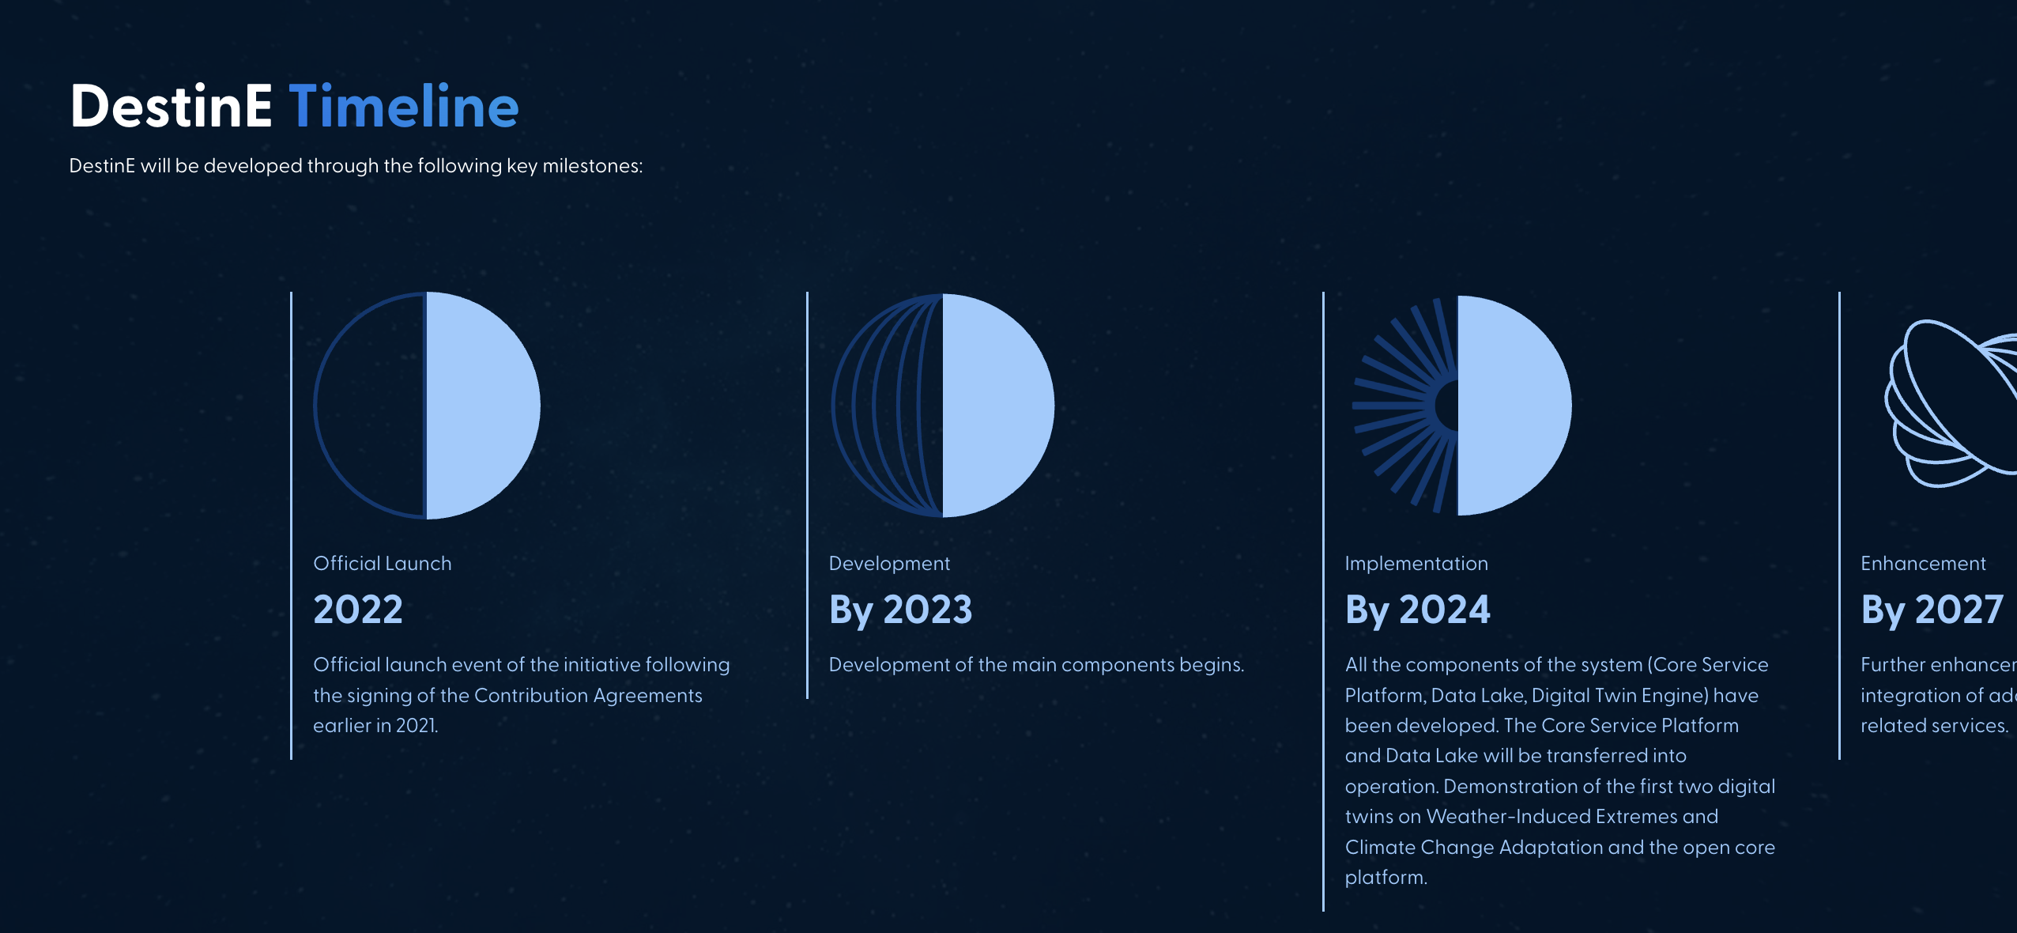

* **About:** The About section has been designed to provide more detailed information about the project and the Entrusted Entities, the technologies that will be leveraged within the core platform, the envisaged activities and the value proposition for the stakeholders.
* **News & Events:** The News & Events section serves to announce and continuously inform the website visitors about the progress on the project implementation and new opportunities for engagement.

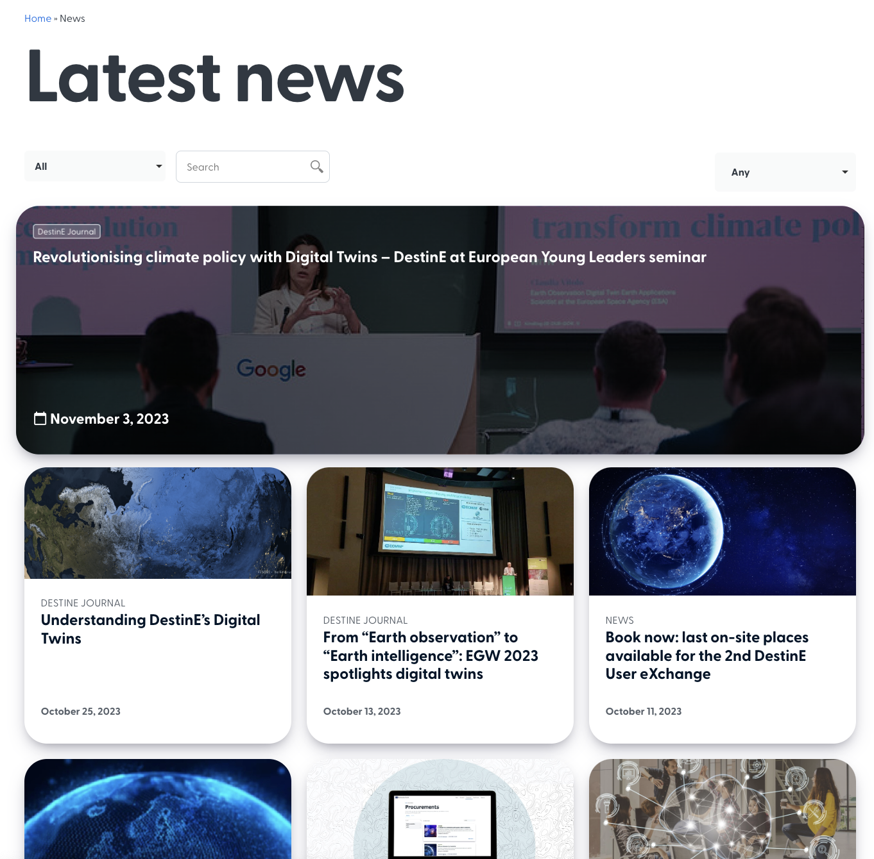

* **Contact us:** The Contact us page ensures that there is an easy-to-use channel for communication and feedback from external users.
* **Privacy Policy** and **Terms of Use** pages: The second website release built upon the developed core sections and has further expanded the engagement channels for the users.

**2nd Release**

The second release complemented the website with such sections and pages:

* **Community** **section:** The Community section describes the advantages of joining the community and the opportunities offered to the members. A secondary page under the Community section includes a dedicated webform to join the Community.
* **Components pages:** A set of secondary pages under the About section provide an overview of the three main components to be delivered by the three Entrusted Entities and the expected impact.
* **Procurements** **section:** The Procurements section displays the list of DestinE open and closed procurements. To ensure an easy navigation, the procurements can be filtered by the funding organization, budget and status. The section is complemented with a secondary page covering external procurements.

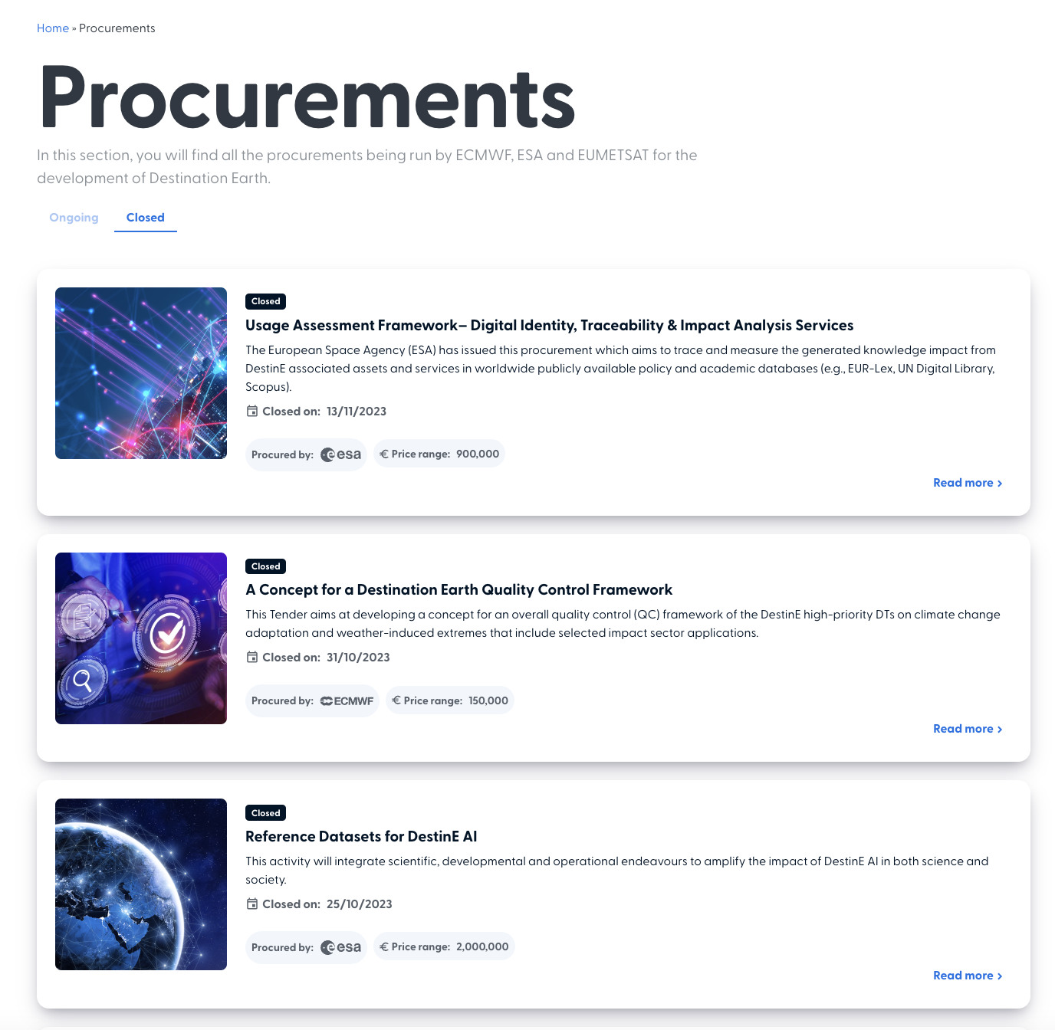

**3rd Release**

The third release, which is currently under development, envisages the launch of:

* The **Use Cases** section provides an overview of the use cases contracted by the three entities. Each Use Case will have a dedicated page that covers the technical details, challenges addressed, developed solution and the expected impact.
* The **National Initiatives** page, which will provide an interactive map that includes key information about the initiatives that are related to the DestinE project at the national level
* The **Communications Kit** page which will provide an easy access to all DestinE’s communications materials, infographics and publications
* A **FAQ** page including the most commonly asked questions related to the project.

The next releases will further expand the website with additional sections including opportunities for engagement and more detailed information about DestinE, such as a MOOCs advertisement page and a section dedicated to Partnerships.

#### Events

Events will be organised to engage stakeholders on-site or online. Events will take the form of DestinE-organised events and third-party events with DestinE visibility.

##### DestinE- organised events

These events, directly organised by the EC, EEs and their contractors are to be listed below.

As a standard operating procedure, events organised by the DestinE initiative through the EC, EEs or their contractors will always be announced in the events section of the website and promoted across DestinE Joint Website channels.

Specifically for DEUC, these events will usually be linked to the implementation of one or more of the campaigns detailed in 4.3. Post-event reports, slides and recordings will then be published on the same event page within 1 week of the event conclusion.

**User eXchanges**

The DestinE User eXchange events series, occurring twice annually and hosted by the EEs gather the main actors that are contributing to the DestinE initiative and act as the flagship event of the initiative that showcases achievements to date. The events are targeted for research centres, universities, industry, public institutions from the science and development community and policy domain, as well as partners, potential partners, contractors, stakeholders, Commission members, and DestinE governance bodies, allowing opportunities for interaction both within the DestinE initiative as well as with stakeholders.

Table 5 User eXchanges carried out to date

|  |  |  |  |
| --- | --- | --- | --- |
| **Event** | **Date** | **Event Link** | **Main Organiser** |
| 1st User eXchange | 15 February 2023 | [[LINK](https://destination-earth.eu/event/welcome-to-the-first-destination-earth-user-exchange/)](https://destination-earth.eu/event/welcome-to-the-first-destination-earth-user-exchange/) | ESA |
| 2nd User eXchange | 13-14 November 2023 | [LINK](https://destination-earth.eu/event/2nd-destination-earth-user-exchange/) | ECMWF |

**Webinars**

Webinars are organised to showcase results or engage stakeholders into contributing to the DestinE initiative. They are typically planned to last 60 minutes and involve two to four speakers, giving visibility to the organisations involved in the initiative. Below is the webinar organised to-date as well as a list of webinars planned with their indicative month.

Table 5 Webinars carried out to date

|  |  |  |  |  |
| --- | --- | --- | --- | --- |
| **Date** | **Title** | **Attendees** | **Event Page** | **Organiser** |
| 11 September 2023 | Information Day: ESA DTE High Performance Earth Observation Digital Twin Components Ready Data Gateway (HIGHWAY) |  | [LINK](https://destination-earth.eu/event/information-day-esa-dte-hpc/) | ESA |
| 19 July 2023 | Roadshow Webinar: Participation and Upcoming Collaboration Opportunities Today | 271 (Unique total viewers) | [Link](https://destination-earth.eu/event/destination-earth-webinar-collaboration-opportunities/) | DEUC |
| 12 June 2023 | 1st ECMWF Destination Earth Capability Providers Meeting |  | [LINK](https://destination-earth.eu/event/ecmwf-1st-destine-contractors-meeting/) | ECMWF |
| 21 April 2023 | Information Day: DestinE Core Service Platform Framework – Advanced Applications and Services |  | [LINK](https://destination-earth.eu/event/information-day-desp-applications-services/) | ESA |

Table 6 Planned Webinars

|  |  |  |  |
| --- | --- | --- | --- |
| **Webinar organiser and planned date** | **Title** | **Description & Target** | **Draft Agenda** |
| DEUC Webinar 1 (July 2023) | Destination Earth: Participation and Upcoming Collaboration Opportunities Today | The Destination Earth initiative is focusing on co-development with its users to ensure a greater responsiveness to the needs of decisions makers at many different geographic levels and in diverse sectors.  In this webinar, you'll discover exciting opportunities to actively participate in the early stages of DestinE. Gain insights into our collaborative approach and learn how your involvement can shape the initiative's future.  Furthermore, we'll introduce our cutting-edge joint website, serving as the primary communication and participation hub.  Target:   * DestinE Contractors * Prospective Users * Interested Parties * Member State Representatives * Media | **Introduction and moderation** – Trust-IT Services (5 mins)  **DestinE Status to-Date** - EC/EE representatives (5 mins)  **Co-development and Engagement Opportunities**   * Brief presentation of the website, future plans and invitation to keep track -Trust-IT (5 mins) * Procurement opportunities (Starion, ECMWF, EUMETSAT – 5 mins each) * Communities of Practice - AUTh (5 mins)   **Upcoming events**   * 2nd DestinE User Exchange - ECMWF (5mins) * BIDS - DestinE Innovation Prize: Ideation Challenge - AUTh/Trust-IT (5mins) * Other upcoming events or opportunities? (10-15mins)   **Audience Q&A** (until no more questions or 10 mins past webinar end time) |
| DEUC Webinar 2 (Dec 2023) | DestinE in action - meet the first DESP use cases | In this phase of Destination Earth, the three core components are being validated by dedicated use cases. In this webinar, you’ll meet the first 5 use cases procured to validate the Destination Earth Service Platform (DESP) being developed by ESA.  The use cases will be applied across a wide range of application domains, including agriculture, natural resource management, fisheries, and the polar area. In practise, use cases will develop software applications that use data and services from DestinE. The purpose is to create predictions that can be used in those different domains and that can inform climate change adaption and extreme weather policy at various levels. During this webinar you can hear directly from each use case about their methods and objectives.  Target:   * DestinE Contractors * Prospective Users * Interested Parties * Member State Representatives * Media | **Introduction & Moderation** - Trust-IT  **Introduction to the DESP** - Serco  **Use Case Lightning Presentations** - Moderator Starion   * Global Fish Tracking System (GFTS) * UrbanSquare * CITYNEXUS * Destination Renewable Energy (DRE) * DestinE Sea Ice Decision Enhancement (DESIDE) * **Audience Q&A** |
| DEUC Webinar 3 (Jan 2023) | Funding opportunities info session: second DESP use cases procurement opportunity | The Destination Earth initiative is focusing on co-development through the procurement of use cases to validate the core components of DestinE.  In this webinar, you'll learn all you need to know for the second round of use case procurements. If you are left with any questions, there is a dedicated time for Q&A during the webinar.  Target:   * Potential Bidders * DestinE Contractors * Prospective Users * Interested Parties * Member State Representatives * Media | **Introduction & Moderation** - Trust-IT  **Introduction to the DESP** - ESA  **Use Case Requirements** - Starion  **Bidding process** - Starion  **Audience Q&A** - Starion |
| DEUC Webinar 4 (Mar 2024) | Engagement, progress and results: connect with our DESP use cases | The Destination Earth initiative is focusing on co-development through the procurement of use cases to validate the core components of DestinE.  In this webinar, you'll learn about the progress and results made by the use cases procured by ESA to validate the Destination Earth Service Platform component.  Target:   * DestinE Contractors * Prospective Users * Interested Parties * Member State Representatives * Media | **Introduction & Moderation** - Trust-IT  **Use Cases Lighting Talks** - Moderation Starion   * Use Case 1 * Use Case 2 * Use Case 3 * Use Case 4 * Use Case 5 * **Update on DESP development** - Serco   **Audience Q&A** |
| ECWMF (11-12 April 2024) | 2nd DestinE Capability Providers Event | TBC | **TBC** |
| DEUC Webinar 5 (Apr 2024) | How to get involved in DestinE communities of practice: a guide to active participation | The Destination Earth initiative is focusing on co-development with its users to ensure a greater responsiveness to the needs of decision makers at many different geographic levels and in diverse sectors.  In this webinar, you'll discover exciting opportunities to actively participate in the DestinE Communities of Practice. Thematic communities of experts providing insight and user requirements to the DestinE development team. Gain insights into our collaborative approach and learn how your involvement can shape the initiative's future.  Furthermore, we'll give a comprehensive guide on how to get involved.  Target:   * Thematic Experts * Researchers & Academia * DestinE Contractors * Prospective Users * Interested Parties * Member State Representatives * Media | **Introduction & Moderation** - Trust-IT  **What is a CoP** - AUTh  **How to contribute** - AUTh  **Using the website’s online tools** - Trust-IT  **Audience Q&A** |
| DEUC Webinar 6 (Jun 2024) | DestinE use cases & how do they address social & economic realities in Europe: discover the new DESP use cases | The Destination Earth initiative is utilising a co-development approach through the involvement of use cases to validate the core components of DestinE.  In this webinar, you'll hear about the DestinE development to date and meet the new use cases procured to validate the Destination Earth Service Platform (DESP) being developed by ESA. During this webinar you can hear directly from each use case about their methods and objectives as well as ask questions directly during the Q&A.  Target:   * DestinE Contractors * Prospective Users * Interested Parties * Member State Representatives * Media | **Introduction & Moderation** - Trust-IT  **DestinE Status and Developments to Date** - ESA  **Validating the Destination Earth Service Platform (DESP) Introduction to Use Cases** (Lightning Round)   * Use Case 1 * Use Case 2 * Use Case 3…   **Panel Discussion and Audience Q&A** (Moderated by Starion)  **Next Steps** (Starion) |

**Community Meetings**

To support the development of Communities of Practice, up to six community meetings will be organised. These community meetings will be defined based on the development and current needs of the COPs and by Trust-IT in conjunction with AUTh.

**Hackathons and the DestinE Innovation Prize**

The DestinE Innovation Prize is envisioned to be a contest where the project will launch a call for submissions of applications of DestinE. Support will be provided by the project through live online workshops for the contestants as well as through the Training Platform. At the end, a winner will be selected based on the creative use of DestinE and the impact of their proposal.

##### Third Party Events

DestinE representatives take part in external events relevant to our stakeholder communities. These are precious opportunities to raise awareness and potentially generate new contacts or community members. We aim to generate visibility for DestinE in at least 6 third party events. To count as having generated visibility, one or more should be fulfilled, highlighting Destination Earth:

* A presentation as part of the programme
* Participation in a panel session
* An exhibition booth
* A poster

#### Below is a list of events where DestinE contributors participated and promoted the initiative.

Table 7 Events where DestinE was presented or given visibility

|  |  |  |  |  |
| --- | --- | --- | --- | --- |
| **Event** | **Date** | **Event Link** | **Type of Participation** | **DestinE Contributors Participating** |
| Science Business Annual Network Conference | 7 February 2023 | [LINK](https://destination-earth.eu/event/ecmwf-sciencebusiness-2023/) | Panel | ECMWF |
| ETP4HPC Conference | 6-9 November 2023 | [[[LINK](https://destination-earth.eu/event/ecmwf-sciencebusiness-2023/)](http://LINK)](https://destination-earth.eu/event/digital-twins-etp4hpc-conference/) | Presentation | ESA, DEUC, EUMETSAT, EODC |
| EGU General Assembly | 23-28 April 2023 | [LINK](https://www.egu23.eu/) | Presentation | EEs, DEUC |
| IGARSS 2023 Town Hall Meeting: Digital Twins for Earth Science | 16-21 July 2023 | [LINK](https://destination-earth.eu/event/igarss-2023-town-hall-digital-twins/) | Presentation | ESA |
| 13th International Symposium on Digital Earth | 11-14 July 2023 | [LINK](https://pcoconvin.eventsair.com/isde23/the-host) | Presentation | ESA |
| VII Convective Permitting Climate Modelling 2023 workshop | 29-31 August | [LINK](https://cpm2023.w.uib.no/) | Presentation | DEUC |
| EuroGEO Workshop 2023 | 2-4 October 2023 | [LINK](https://egw2023.eurac.edu/program-outline) | E-Poster | ESA, ECMWF, DEUC |
| Ireland's Destination Earth Workshop | 4 October 2023 | [LINK](https://destination-earth.eu/event/irelands-destination-earth-workshop/) | Presentation | EEs, CSC, Deltares |
| The Open-Earth Monitor Global Workshop 2023 | 4 October 2023 | [LINK](https://destination-earth.eu/event/the-open-earth-monitor-global-workshop-2023/) | Presentation | ESA, DEUC |
| 20th ECMWF workshop on high performance computing in meteorology | 9-13 October 2023 | [LINK](https://destination-earth.eu/event/20th-ecmwf-hpc-workshop/) | Presentation | ECMWF |
| 2nd National DestinE Workshop - Poland | 12-13 October 2023 | [LINK](https://destination-earth.eu/event/2nd-national-destine-workshop-poland/) | Presentation | ESA, ECMWF |
| UN-WHO International Conference on Space and Global Health | 1-3 November 2023 | [LINK](https://destination-earth.eu/event/un-who-geneva-conference-space-health/) | Presentation | ESA |
| Big Data from Space 2023 | 6-9 November 2023 | [LINK](https://www.bigdatafromspace2023.org/) | Satellite Event & visibility at ESA booth. | ESA, EUMETSAT, DEUC |

Additionally, external events that featured DestinE are showcased in the [joint DestinE website events section](https://destination-earth.eu/event/).

Below is a list of potential third-party events where DestinE is targeting visibility in.

Table 8 Relevant events for participation

|  |  |  |  |
| --- | --- | --- | --- |
| **Event title** | **Event date** | **Event link** | **DestinE Contributors Participating** |
| AGU23 | 11-15 December 2023 | [LINK](https://www.agu.org/Fall-Meeting) | ESA |
| European Space Conference | 23-24 January 2024 | [LINK](https://spaceconference.eu/) | ECMWF |
| ECMWF Webinar with EMS | 21 February 2024 | TBC | ECMWF |
| EuroHPC Summit 2024, Belgium | 18-21 March 2024 | TBC | TBC |
| 2nd DestinE Capability Providers Event | 11-12 April 2024 |  | ECMWF |
| EGU General Assembly 2024 | 14-19 April 2024 | [LINK](https://www.egu24.eu/) | ESA, DEUC |
| ISC HPC 2024, Germany | 12-16 May 2024 | [LINK](https://www.isc-hpc.com/submissions-2024.html) | TBC |
| ESA-ECMWF Workshop on Machine Learning for Earth System Observation and Prediction | 7-10 May 2024 | [LINK](https://www.ml4esop.esa.int/thematic-areas) | ESA, ECMWF |
| IGARSS 2024 | 1 July 2024 | [LINK](https://www.2024.ieeeigarss.org/) | ESA, DEUC |

#### Videos

Videos are a fundamental element of online and offline outreach. We are going to produce **up to 6 videos** exploring the DestinE vision and the use cases coming out of the DEUC project. These videos will be between 2-5 minutes each and will be geared towards non-technical audiences. At least one of these videos will be a general introductory video for the DestinE initiative and the other 5 will be dedicated to showcasing the use cases and their impact.

Videos will also play a crucial role in community engagement during events. In the digital age where attention spans are shorter, videos have the power to captivate and convey information more effectively than static images. By maximising the use of videos, we can create an immersive experience for participants and amplify the impact of event insights dissemination. Short video pills, in particular, offer an engaging and dynamic format that can quickly grab the audience attention during and even after the event. Whether it is introducing event sessions or sharing brief interviews with speakers, these video pills create event experiences that foster connection, inspire learning, and drive community engagement.

Based on the 1st round of use cases procured by ESA and Starion, and to ensure that we can also produce videos for the later use cases, we plan to produce videos based on domains that DestinE can potentially impact. The 1st batch of use cases can yield the first 3 videos. These can be expanded if use cases in the same domain are procured during the 2nd round. Otherwise, we have allotted two videos for other potential domains not already covered by the first round.

**Timeline**

|  |  |
| --- | --- |
| **Topic** | **Date** |
| General promotional video | September 2023 (delivered) |
| DestinE for the Oceans (GFTS & DESIDE) | March 2024 |
| DestinE for our Cities (Urban Square & CITYNEXUS) |
| DestinE for Energy (DRE) |
| Fourth use case video | June 2024 |
| Fifth use case video |

#### DestinE Promotional Kit and other Collaterals

To support the different organisations promoting the DestinE initiative, a general DestinE Promotional Kit was developed. This contains the project’s general roll-up banner, stakeholder-focused flyers, a more detailed brochure, infographics, poster, slide deck, general video, logo and standard description will be provided to partners and made publicly available on the DestinE Community Portal.

To enable this, a visual identity guidelines document has been prepared in collaboration with the DestinE Editorial Board.

**Timeline for delivery of promotional kit**

Updates are periodically applied to the promotional kit and are recorded quarterly in the deliverable D4.2 Promotion Package.

#### Email and Newsletters

Email is seen as one of the most valuable channels of communication based on how it is used within this communication plan. Emails are only sent to individuals that have expressly requested to be informed of DestinE or the DEUC project’s developments and are gathered with full application of the GDPR requirements and hence it provides us with a direct one-on-one channel with each stakeholder individually.

Newsletters are sent using a branded template developed especially for the purpose, in line with DestinE branding. Aside from the regular quarterly newsletters, there might be special issues in case of particularly important deadlines or events.

The platform chosen for this is Mailjet, as it is a reliable EU-based provider. A signup form is embedded in the website, to make it very easy for people to subscribe.

#### Press and media

A Press Office is set-up to monitor the media coverage of the DestinE initiative. The press office will also connect any press inquiries to key spokespersons of the DestinE initiative. Spokespersons will be appointed based on each EE’s main scope of activities. The main goal of the press office will be to encourage as much coverage of the DestinE initiative in various third-party media outlets or channels.

#### Social media

At present, promotion of the DestinE initiative will be carried out through the EEs own social media channels. For messaging specifically related to the DEUC project, ESA’s social media channels will be the prime social media channel to be used.

The Editorial Board may decide to establish social media channels specifically tied to the Joint DestinE Website.

# Monitoring

Monitoring the implementation of the Communication and Engagement strategy is crucial to assess whether it is achieving its intended goals.

Through various tools, DestinE is implementing a feedback loop that collects data from its website and social media channels to identify valuable insights, patterns, trends and challenges related to how the community interacts with these channels that will ultimately allow DestinE to investigate and implement the adjustments needed to improve the effectiveness of its strategy.

To effectively monitor the implementation of the current strategy the following tools are being implemented.

## KPIs dashboard

To measure the website and social media activities, a Google Looker studio dashboard will be created.

Google Looker Studio is a business intelligence and analytics platform that allows users to easily access, analyse, and visualise their data through a user-friendly interface by creating and sharing dashboards and reports.

With Google Looker Studio, DestinE will be able to:

* **Easy data exploration**: Explore its data quickly and easily, without the need for complex queries or coding.
* **Collaborative analytics**: Collaborate on data analysis and share insights internally with the consortium to improve decision-making.
* **Customisable dashboards**: Build and share dashboards tailored to track the specific KPIs of each campaign.

## Matomo analytics

Matomo is a web analytics platform that offers businesses complete control over their data. It is open-source software that provides a range of features to help companies understand their website traffic, user behaviour, and conversion rates. Matomo analytics is designed to give businesses the data they need to make informed decisions about their online strategy.

With Matomo analytics, DestinE will be able to:

* **Complete data ownership**: DestinE will have complete ownership and control over its data ensuring complete privacy and security.
* **Customisable dashboards**: Matomo Analytics offers customisable dashboards that will allow DestinE to create its own reports and visualisations to better understand website traffic and user behaviour.
* **Real-time tracking**: Matomo analytics tracks website traffic in real time, providing DestinE with up-to-date information about its website visitors and their behaviour.
* **GDPR compliance**: Matomo Analytics is GDPR compliant, ensuring that DestinE can collect and use data in a way that is compliant with the EU's General Data Protection Regulation (GDPR).
* **Customisable tracking**: DestinE will be able to customise its tracking settings to ensure that it is collecting the data needed to make informed decisions.

## Community database

A database of DestinE community members, or individuals that are actively contributing to the Destination Earth initiative or who have requested to be informed of the initiative’s developments, or users of the components, is stored safely within the repository of the DEUC project. This community is accessible only to the data controllers as indicated in the Destination Earth Joint Website Privacy Policy. This community database is being used to track the growth of the DestinE Community.

With new DestinE user interfaces expected to be brought forward through the launch of the different components for public access, this means new DestinE community members as defined above may be gathered in the respective DestinE component databases not under the control of the DEUC project. The DEUC project, to be able to track the achievement of the new ambitions of the Community Building and Management Strategy (i.e., expansion of the original target from 400 community members by mid 2024 to 5000 by end of 2024) will attempt to gather data on DestinE users.

# Conclusions and next steps

The DEUC project’s Community Building and Management Strategy and Workplan provides a strategy and implementation plan on growing the community of potential users, co-creators, supporters and observers of DestinE. This document is the first snapshot and baseline for these activities.

The CBMS covers the strategy for growing the DestinE community as well as the communication and engagement activities planned. As envisioned after its first publication, this plan continues to be a live or working document that is updated based on the development of the DEUC project and the DestinE initiative.

Although the scope of this document is limited to the ESA-funded DEUC project, and other similar efforts were in place by the other DestinE entrusted entities, before the introduction of this strategy, it is recommended that this document sets the foundation to converge towards a coordinated approach by Phase 2.

1. Baulenas, E., Bojović, D., Urquiza, D., Terrado, M., Pickard, S., González, N., & St Clair, A. L. (2023). User selection and engagement for climate services coproduction. *Weather, Climate, and Society*, *15*(2), 381–392. https://doi.org/10.1175/wcas-d-22-0112.1
2. This is a new metric based on a readjusted community members target following surpassed targets & new CBMS ambition of 3000 community members by end of 2024. This largely depends on being able to synchronise data collection between the DESP and DEUC projects as DESP users would be considered as DestinE community members.
3. A moving benchmark is carried out by first measuring the results for the first period. This will be the benchmark set and the goal for the next period is to surpass this benchmark by 10%. The last benchmark remains until it is reached. This ensures that goals are realistic as they are based on past results while also aiming for continuous growth.